Incoherent quantum control based probabilistic logic
Anton Tkachenko
PhD Candidate
Western Norway University of Applied Sciences,
Department of Computer science, Electrical engineering and Mathematical sciences, Bergen, Norway
E–mail: Anton.Tkachenko@hvl.no
Quantum computing is one of the most promising and important fields of modern science. Despite a number of studies conducted, there are still many unresolved issues and opportunities that can be investigated. One of these possibilities is the use of quantum effects in probabilistic calculations. Quantum computing itself is probabilistic, but in this paper we would like to consider a more flexible probabilistic construction. Along with the usual scheme of quantum computing, where the applied logic gates are based on unitary transformations, there is another approach, namely the operator sum or Kraus operators representation [4]. This type of operator belongs to the type of incoherent quantum operations [1]. So a completely positive trace-preserving map of the Kraus operator sum representation loos like:
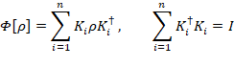
These are known as noise operators(error operators), especially in the context of quantum information processing, where the quantum operation represents the noisy, error-producing effects of the environment. Further, we present the main logical gates based on the Kraus operators, without considering the presence or absence of initial environment-state correlations [3]. It is also important to clarify that probabilistic gates are constructed in such a way that they lead to similar ones when applied to binary quantum logic given in Table 1. This means that when applying incoherent control to a qubit, the result of such operations is equivalent to applying unitary transformations (coherent control), and therefore such a system is not of interest. For this reason, we will further consider logic with a base of more than two, the obvious choice, in this case, will be trits (in our case, qutrits), due to the fact that the unitary control and properties of such systems are studied [2]. Thus, using both coherent and incoherent control, we can control the system, as shown figure bellow.

In the case of a tree state system, density matrix state-space could be mapped to two-dimensional simplex, where:
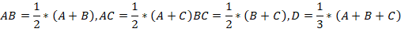
Here the unitary operations are represented by three medians (cause two-dimensional simplex is equilateral); however, we are not considering the rotations related to the matrix "C" because the negotiation of uncertainty doesn't make sense. Now consider the gates in table 1.

Binary operations | Probabilistic operations
Not: | 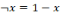
And: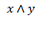 | 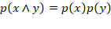
Or: 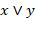 | 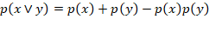
Xor: 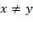 | 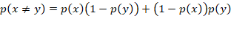
Table 1. Binary and probabilistic operations.
PNOT:
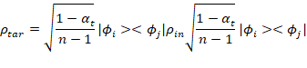
PAND
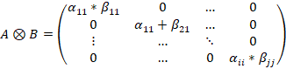
POR
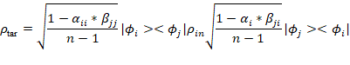
PXOR
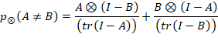
Thus, we have shown that the implementation of quantum state control methods for probabilistic logic can be constructed based on incoherent control and adapted to calculate classical probabilities. Other issues that were not considered here, but essential, are Bayes probability and quantum entanglement, however, these questions are too extensive for this format, so links are given.
Литература
- Baumgratz T., Cramer M., Plenio M. Quantifying Coherence. Phys. Rev. Lett. 140401 (2004).
- B., Yu Z.,Fei S. Geometry of Quantum Computation with Qutrits. Sci Rep 3, 2594 (2013)
- Pechen A., Rabitz H. Incoherent Control of Open Quantum Systems. Math Sci 199, 695–701 (2014).
- Hayashi H., Kimura G., and Yukihiro O. Kraus representation in the presence of initial correlations Phys. Rev. A 67, 062109 (2003)

