Unusual synthesis of indenones through cyclization of phenylcarbonyl allene under superacidic conditions
Mammeri Oussama Abdelhamid
PhD student, 1st year
Saint Petersburg State University, Institute of Chemistry, Saint Petersburg, Russia
E-mail: oussamacosa@gmail.com
Allenes have attracted much attention since they are useful and unique precursors in organic chemistry [1]. However, transformations of allenes under superelectrophilic activation by Bronsted and Lewis (super)acids have not been developed very much up to the moment. Phenylcarbonyl substituted allene 1 was synthesized from propiophenone (see Scheme). Three reaction pathways may be proposed for cyclization of 1 in the superacid СF₃SO₃H (triflic acid, TfOH). Apart from protonation of carbonyl oxygen of 1 in TfOH, protonation of the allene triad may proceed on three carbons C4, C2 or C3, leading to dicationic intermediates A, B, C, correspondingly. These three ways may lead to different cyclization product 2, B1 or C1. However, only indanone 2 was quantitatively formed from 1 in TfOH at room temperature for 30 min. This way of protonation of allene 1 on terminal carbon C4 with formation of vinyl dication A is quite unusual, since usually electrophiles are added to central carbon atom of allene system with formation of allyl cations.
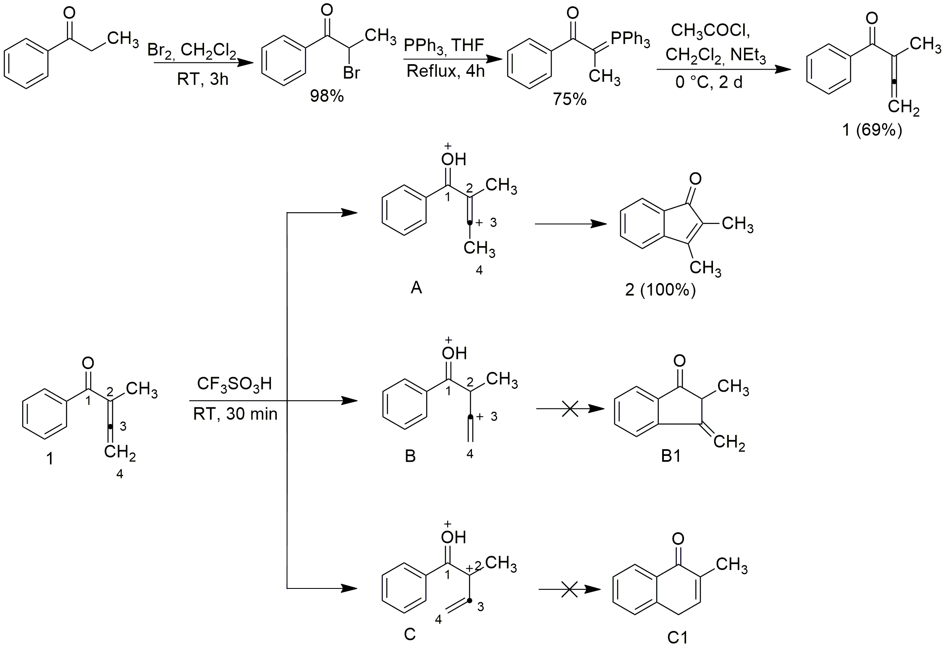
References:
- Hopf, H.. Allenic Hydrocarbons – Preparation and Use in Organic Synthesis. Modern Allene Chemistry:2004, 185-241.

