Effect of annealing temperature on structure and orientation of extruded PVDF films
D.I. Gerasimov, G.K. Elyashevich
Post-graduate student, 2 year
Institute of Macromolecular Compounds, Russian Academy of Sciences, Saint- Petersburg, Russia
E-mail: dmitrygerasimov1997@gmail.com
The oriented films of polyvinylidene fluoride (PVDF) have been obtained by melt-extrusion technique (Fig.1) and subsequent annealing. Commercial grades PVDF (Kynar-720, M_{w} = 190000 g·mole⁻¹, T_{m} = 172⁰C) were used for the samples preparation. Orientation degree of the melt at extrusion stage was characterized by melt draw ratio (λ). The annealing was performed in isometric conditions (fixed ends of the samples). Crystalline structure of the extruded and annealed films was investigated by DSC and X-ray scattering experiments.

Table. Structure characteristics of the extruded PVDF films.

Melt draw ratio,  λ | Thickness,  δ, µm | Degree of crystallinity, χ, % | Orientation factor,  f_{c} | ρ_{a},  g/cm³
15 | 120 | 45.0 | 0.46 | 1.661
29 | 61 | 45.5 | 0.56 | 1.659
44 | 39 | 46.7 | 0.61 | 1.653
76 | 23 | 48.8 | 0.69 | 1.642

It is seen in the Table that the increasing of λ leads to some rise of crystallinity degree (χ) and a significant growth of the orientation factor. Density of all extruded films was 1.78 g·cm³. As a result, an increase in crystallinity is accompanied by a decrease in the density of the amorphous phase (ρ_{a}). The extruded films were annealed, and the dependences of the structure characteristics on annealing temperature (T_{ann}) were obtained (Fig.2). The annealed films had the higher crystallinity and orientation factor (0.8-0.9 for annealed films) than extruded ones.

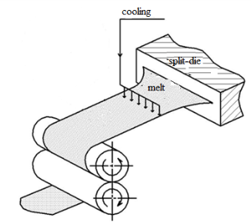
Fig.1. Melt-extrusion process of the polymer films preparation. | Fig.2. Dependence of crystallinity degree χ on annealing temperature T_{ann}.

As seen at Fig.2, the dependence of crystallinity degree (χ) on T_{ann} has nonmonotonic path and demonstrates minimum at T_{ann}=150ºС. As it was shown by DMA the mobility of chains in crystals of PVDF appears at 140-150ºС. At the lower temperatures the chain mobility in amorphous phase increases with temperature and initiates disorientation of molecular chains on the surface of crystallites. As a result, the parts of chains pass from crystallites into the amorphous phase, and the degree of crystallinity decreases. At T_{ann} ≥ 150ºС the chains mobility in the crystallites makes it possible the structure rearrangement in the crystalline part and the significant growth of χ due to involving of the chains from amorphous phase in the crystals.
The morphological rearrangements at annealing of PVDF films results in the formation of structures which differ greatly from the initial extruded ones. The analyses of the crystalline structure of the studied samples makes it possible to predict their behavior during further processing in order to obtain ready-to-use polymer products with desired functional properties.

