New chemical transformations of pinolidoxin and the origin of its artifacts
Radiupov V.E.,¹ Slukin A.P.,¹ Fedorov A.N.,² Dalinova A.A.²
Student, 4 course of Bachelor’s degree
¹Saint-Petersburg state university of industrial technologies and design,
St. Petersburg, Russia
²All-Russian institute of plant protection, St. Petersburg - Pushkin, Russia
e-mail: vradyupov@mail.ru
The ten-membered lactones (nonenolides) represent significant potential as models for the development of pesticides with low-toxic activity for non-target organisms. Pinolidoxin 1, first isolated from Ascochyta pinodes, is a representative of this extensive class due to its substantial phytotoxic activity [1]. In our study 1 was biotechnologically obtained from pea’s pathogen Didymella sp. Further chemical modification of 1 allows to obtain semi-synthetic derivatives as potential herbicides with mechanisms of action different from those of commonly used agrochemicals. Although there are several derivatives of 1 being published up to date chemical stability and reactivity of these type substances were not investigated. During the search for new phytotoxic derivatives of pinolidoxin 1 its unusual chemical behavior was discovered and described in our work.
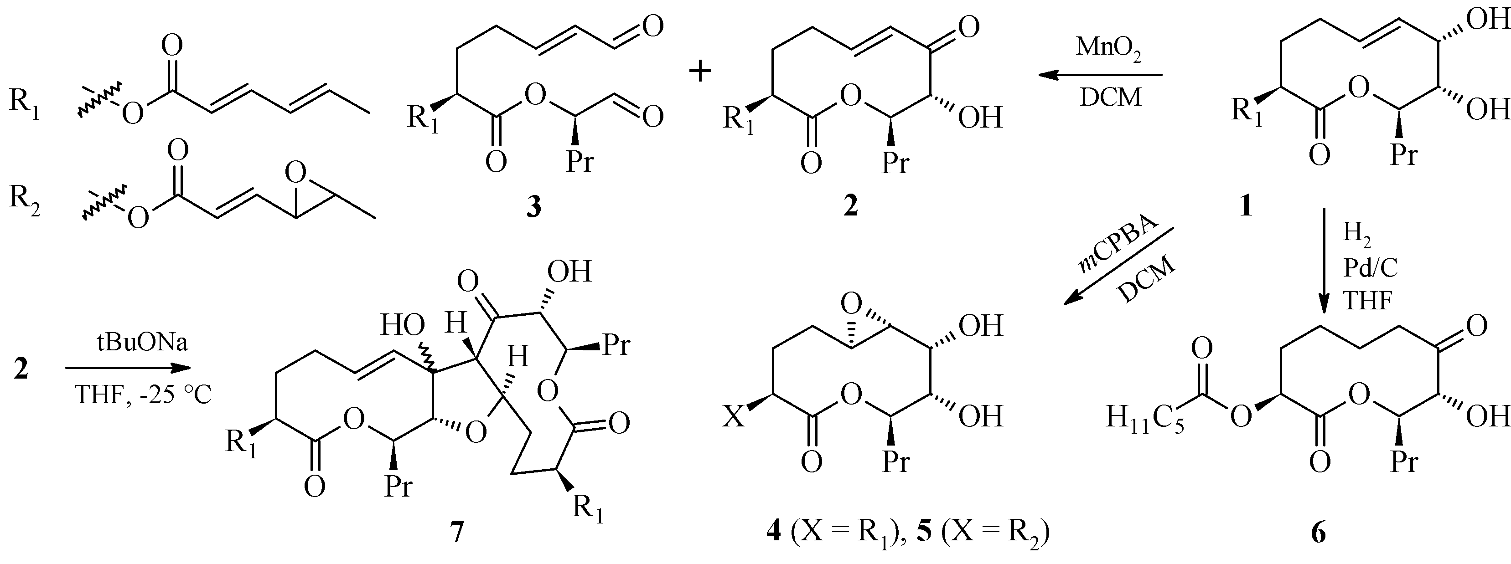Scheme 1. Chemical modification of pinolidoxin
The oxidation of compound 1 using MnO₂ gives C7-oxidized alpha-ketol 2 alongside with dialdehyde 3 formed by C7-C8 cleavage with the yield ratios of 35 and 44% respectively. The epoxidation 1 with m-CPBA involves two regions: lactone cycle and sorbic acid residue of the molecule. The major 5,6-epoxide 4 was isolated in 56% yield. It is noteworthy that ring epoxidation gives only 5R,6R diastereomers (NMR NOESY confirmed). Hence previously reported absolute configuration of substance 4 isolated from A. pinodes and P. bellidis should be revised [1-2]. Furthermore, compounds 2 and 4 appeared to be the products of pinolidoxin 1 autoxidation (HPLC-MS confirmed) thus previously reported epoxide 4 suspected to be an artifact rather than compound of natural origin. Hydrogenation of 1 in a presence of Pd/C occurs with allylic alcohol moiety transposition into the saturated ketone 6. Interestingly, under sodium tert-butoxide compound 2 undergoes dimerization through Baylis-Hillman type reaction into dimer 7 with 62 % yield. Structures and composition of derivatives 2-7 was confirmed by spectral methods (1D/2D NMR and ESI-MS).

This work was supported by the Russian Foundation for Basic Research (grant № 22-16-00038).
References
- Evidente A., Capasso R., Abouzeid M.A. et al. Pinolidoxin, a phytotoxic nonenolide from Ascochyte pinodes // Phytochemistry. 1993. Vol. 34. №. 4. P. 999–1003.
- Wang W.X., Zheng M.-J., Li J. et al. Cytotoxic polyketides from endophytic fungus Phoma bellidis harbored in Ttricyrtis maculate // Phytochemistry Letters. 2019. Vol. 29. P. 41–46.

