Extraction of U(VI) and Th(IV) by solvation-anion mechanism with tetradentate phenanthroline ligands
Wang Q.,¹ Gutorova S.V.,¹ Matveev P.I.¹
Student, 1st year of Master’s degree
¹Lomonosov Moscow State University, Department of Chemistry, Moscow, Russia
E-mail: tsiushi.van@chemistry.msu.ru
Reprocessing of spent nuclear fuel (SNF) has always been a serious problem troubling mankind. Complexation of organic ligands with actinides is the basis of nuclear technology used for reprocessing of SNF. In order to minimize the amount of radioactive waste generated during the SNF retreatment process and recover the U(VI) and Pu(IV) for further use as a new nuclear fuel, new extractants are being studied. Phenanthroline diamides (L) demonstrated the unique ability to extract uranium from a nitric acid solution into a polar organic solvent through a novel extraction mechanism to form a complex of tight ion-pair {[UO₂LNO₃]⁺[UO₂(NO₃)₃]⁻} with a stoichiometric ratio of U:L 2:1[1]. In this light Pu(IV) and transuranium elements (TRU) extraction in U(VI) excess is of a great interest as a possible route for U(VI)/Pu(IV)/TRU separation. In this work we investigated the extraction of Th(IV), as a Pu(IV) imitator, and Am(III) in presence of macroquantities of U(VI) by L in the solvent F3. A combination of spectroscopic methods (UV-vis, Raman spectroscopy) and solvent extraction experiments was used to demonstrate the competition of Th(IV) and U(VI) complexation in case 5 – 200 g/L concentration range in initial solution.

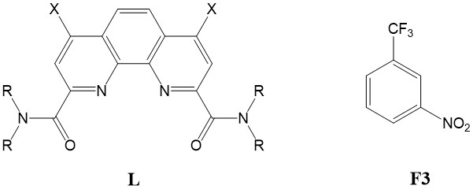
Figure 1. Structures of 1,10-phenanthroline-2,9-diamides (L) and solvent F3.

Literature
- Gutorova S. V., Matveev P. I., Lemport P. S. Solvation-Anionic Exchange Mechanism of Solvent Extraction: Enhanced U(VI) Uptake by Tetradentate Phenanthroline Ligands // Inorganic Chemistry. 2023. P. 487-496.

