Study of poly[Ni(CH₃OSalen)]_{n} polymerization processes and their influence on energy storage properties
Novoselova J.V., Lukyanov D.A., Levin O.V.
Ph.D. student
St. Petersburg State University, Institute of Chemistry, St. Petersburg, Russia
julivit.n@yandex.ru
Polymers based on coordination compounds of transition metals with Schiff bases ([M(Schiff)]) are promising materials for energy storage, sensor and optoelectronic devices, as well as photo- and electrocatalytic systems due to their sufficient chemical stability and electrical conductivity. Currently, obtaining polymers based on salen-type complexes is mainly carried out by electrochemical polymerization (Fig. 1). This method leads to the formation of sufficiently strong but relatively thin (1-5 µm) coatings on the electrode surface, which, in turn, creates certain obstacles to scale-up in the conditions of industrial production. As an alternative approach chemical polymerization method can be used, which allows to obtain polymer with high quantitative yield and minimize energy consumption for the production process. In spite of this, to date there is no confirmation of the identity of the electrochemical properties of salen-type polymers obtained by chemical and electrochemical polymerization methods. To solve this problem, it is necessary to develop and optimize synthetic approaches and technological processes for depositing polymers on conductive substrates, with subsequent testing of the properties of the obtained coatings.
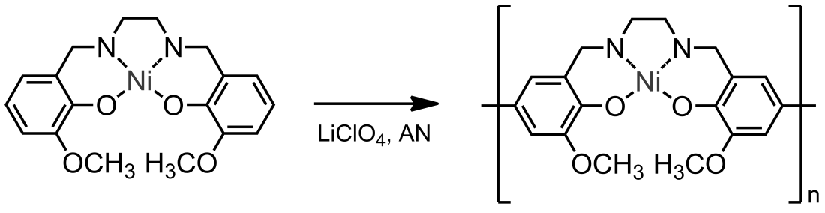
Fig. 1.Synthesis of poly[Ni(CH₃OSalen)]_{n} by electrochemical polymerization
The paper presents two methods of obtaining polymers based on the [Ni(CH₃OSalen)] complex using chemical and electrochemical polymerization. The main structural factors influencing their electrochemical properties are revealed.
Scientific research was partially performed at the centers of Physical Methods of Surface Investigation, Nano-technology, Magnetic Resonance, Optical and Laser Materials Research of SPSU Research Park. Project was funded by RSF (#19-19-00175).

