Preparation and characterization of dexamethasone conjugates with amphiphilic polypeptides
Gladnev S.V.¹, Zashikhina N.N.², Korzhikova-Vlakh E.G.^{1,2}
¹Student, 1st year of master's degree,
¹Saint-Petersburg State University, Institute of Chemistry, Saint Petersburg, Russia
²Institute of Macromolecules Compounds, Russian Academy of Sciences, Saint Petersburg, Russia
E-mail: serg13glad@gmail.com
Dexamethasone is a broad-spectrum synthetic steroid used in ophthalmology to treat inflammatory diseases of the anterior and posterior segments of the eye. However, the use of dexamethasone is limited by its low solubility and bioavailability, rapid elimination from the body, and the need to maintain therapeutic concentration in the target cells for a long time. Covalent conjugation of dexamethasone with polymeric carriers is a promising strategy to overcome the existing drawbacks. Polypeptides are the most interesting class of polymers for this purpose because they are biocompatible, biodegradable, and capable of self-organization into nanoparticles. In this work, amphiphilic copolymers of poly(L-glutamic acid-co-D-phenylalanine) were used for conjugation.
New intravitreal dexamethasone delivery systems based on dexamethasone conjugates with polypeptides containing a combination of two linkers with different structures were developed. The conjugate synthesis was performed in three stages. In the first step, dexamethasone derivatives were obtained by reaction with succinic or 2-methylsuccinic anhydride in the presence of 4-dimethylaminopyridine. In the second step, the polymer was modified with a linker, namely (N-Boc-protected-ethylenediamine), by the activated ester method. After removal of the protective group, a polypeptide containing free amino groups was obtained. At the final stage, the formed polymer was covalently bound to dexamethasone derivatives by the activated ester method. The structures of the synthesized substances were confirmed by ¹H NMR spectroscopy (Fig.1). In addition, the covalent binding of dexamethasone to the copolymer was confirmed by ¹H DOSY NMR spectroscopy. The amount of bound DEX was calculated using HPLC analysis of the sample after alkaline hydrolysis of conjugates. The dexamethasone content was 37.5 and 26.8 μg/mg of polymer for conjugates with succinic and 2-methylsuccinic linker, respectively.
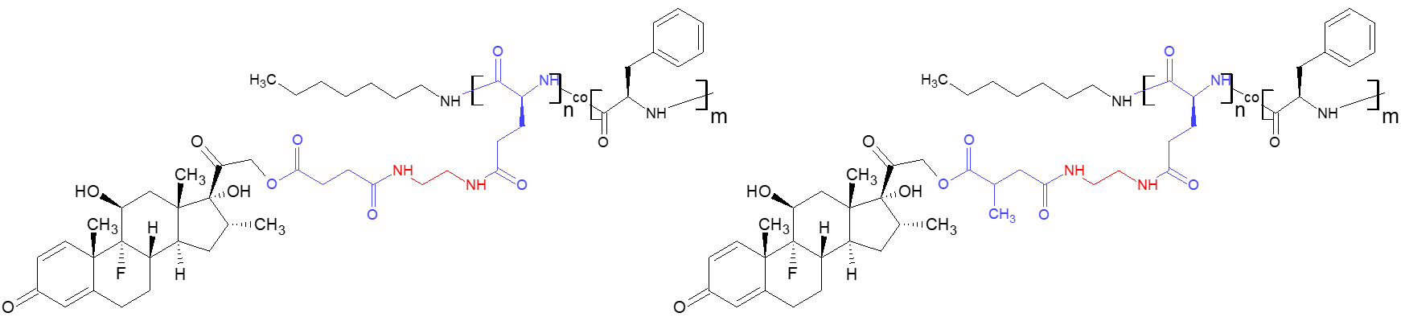
Fig. 1. Chemical structures of the synthesized conjugates
The synthesized polypeptides and their conjugates were used to produce narrow-dispersed nanosized particles with physicochemical characteristics suitable for use as drug delivery systems. The hydrodynamic diameters of the particles were obtained by dynamic light scattering and nanoparticle tracking analysis. The morphology of the particles was studied by transmission electron microscopy. The stability of the particles during storage in phosphate buffer solution and in the presence of proteins was evaluated. The effect of dexamethasone conjugation and linker structure on the hydrodynamic characteristics of the formed particles and dexamethasone release rate in phosphate buffer solution and vitreous was investigated.
Acknowledgements. This work was supported by the Russian Ministry of Education and Science of the Russian Federation within State Contract 14.W03.31.0025 (Megagrant).

