Spatial heterogeneity and microspatial distribution of testate amoebae communities in northern submountain territories (Northern Urals)
Zhu Qihan
Postgraduate student, 2nd year of study
Shenzhen MSU-BIT University,
Faculty of Biology, Shenzhen, China
E-mail: 2120210082@smbu.edu.cn
Microorganisms can provide valuable insights into the current understanding in community assembly [Wanner et al., 2008]. Soil testate amoebae as free-living protists are ecologically important in soil fauna [Wilkinson, Mitchell, 2010]. However, their community assembly rules are poorly investigated. In the present study, using principle component analysis and analysis of species co-occurrence, we aim to investigate the characteristics and assembly rules of testate amoebae communities from sub-crown locations and typical biotopes in a pristine forest.
The frequency histograms (Fig. 1) of testate amoebae species from sub-crown locations revealed an uncommonly large number of species with high frequency, which can be a cue for high resemblance of environmental conditions for testate amoebae in sub-crown biotopes.

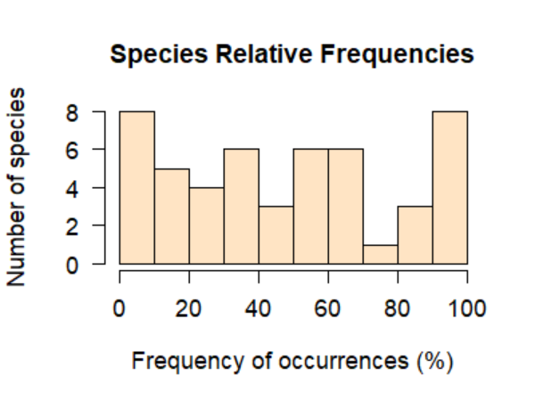
Fig. 1. Frequency histograms of testate amoebae species in the 23 samples taken from sub-crown locations

Nevertheless, the result of Principal Component Analysis (PCA) on the testate amoeba sub-crown communities clearly suggested a heterogeneity in species composition between woody sites and woodless sites (Fig. 2).

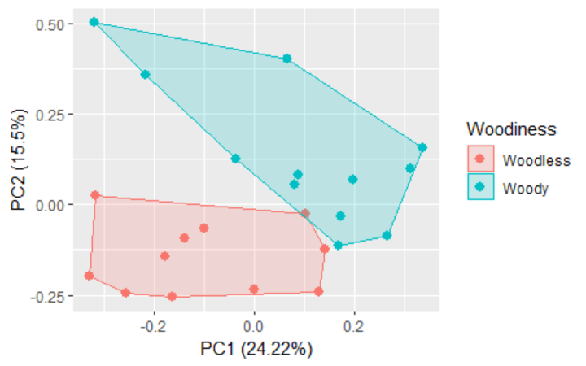
Fig. 2. PCA ordination plot (site scores) for 23 samples from sub-crown locations

Further perspectives of this study are related to the analysis of pair-wise species co-occurrence.
References
1. Wanner M., Elmer M., Kazda M., Xylander W.E.R. Community Assembly of Terrestrial Testate amoebae: How is the very first beginning characterized? // Microbial Ecology. 2007. Vol. 56, iss. 1. P. 43–54.
2. Wilkinson D.M., Mitchell E.A. Testate amoebae and nutrient cycling with particular reference to soils // Geomicrobiology Journal. 2010. V. 27, iss. 6–7. P. 520–533.

