Palaeoecological reconstruction of hydrological regime using testate amoebae analyses from peat deposits on the territory of forest-steppe zone, Russia
Sun Feiyang¹, Mazei Yu.A.^{1,2}, Tsyganov A.N.^{1,2}, Babeshko K.V. ^{1,2}
Postgraduate student, 2nd year of study
¹Shenzhen MSU-BIT University, Faculty of Biology, Shenzhen, China
²Moscow State University named after M.V. Lomonosov,
Faculty of Biology, Moscow, Russia
E-mail: sunfeiyang0807@163.com
The aim of the work is to provide quantitative hydrological reconstruction of peat deposits on the studied area using fossil testate amoebae (TA) communities.
Testate amoebae are unicellular eukaryotic organisms covered by rigid external covering called shell and are very sensitive to hydrological fluctuations, particularly in mires. The last peculiarity can be used as paleoenvironmental indicators to reconstruct the changes of water table depth level in peatlands and construct long-term community dynamics and functional changes.
The study area is located in the forest-steppe zone of East-European plane and belongs to the landscape province of the Volga Region. The sampling point is located in “Verkhozim” mire (N 52.985617, E 46.459322). The depth of peat deposits is 2,5 m. Peat cores were extracted using handle Russian peat corer.
Totally, 54 species and subspecies of testate amoebae were identified during Verkhozim peat profile microscopy. TA analyses show that since ~4000 till ~2000 cal.yr. BP mean WTD were 4.4 ± 6.6 cm (SD). Then, unstable hydrology fluctuations were observed till ~1300 cal.yr BP (mean value 10.8 ± 6 cm). Further, till ~780 cal.yr. BP WTD were rather high signalizing high moisture conditions (5.2 ± 5.9 cm). After short gap in hydrological reconstruction caused possibly by high decomposition rate water table first increase and than show tendency to drying closer to surface (average WTD is 17.3 ± 6.3 cm).
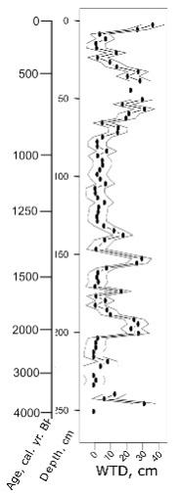
Fig. 1. Water table depth reconstruction of the Verkhozim peat profile based on testate amoebae communities with time scale based on radiocarbon dating (cal.yr. BP).
Generally, testate amoebae analyses show its high sensitivity to water table reconstructions. Water table level are quite unstable during last ~4000 years in the studied mire showing tendency to drying in modern period. The peaks of high WTD meaning may be explained when comparing with other proxies in further analyses of peat deposits.

