Prediction of skin permeability coefficient by means of coarse grained molecular dynamics simulations
Yang A., Bozdaganyan M.
Student, 2nd year of the nanobiotechnology
Shenzhen MSU-BIT University, 1 International University Garden Road, Dayun New City, Longgang District, Shenzhen City, Guangdong Province, 518172, China
E-mail:smbuamy@gmail.com
Transdermal drugs and cosmetics are of great significance in the medical and cosmetic industries. The cost of experiments on human skin is relatively high, and the physiological gap between human skin and the substitutes such as pig skin, monolayer cells or chemical biofilms is too large. Using molecular simulation to study model skin cell membranes can provide predictions of experimental parameters such as permeability coefficients. Different concentrations of active ingredients and compound combinations can bring different penetration effects through the skin. This research mainly focuses on simulations of interactions of different chemical compounds with model skin bilayer. MARTINI force field and the Gromacs software is used in the study. The ratio of ceramide, cholesterol and free fatty acid of the skin cell membrane is 1:1:1. The membrane is equilibrated at 310 K during 0.5 microsecond. Firstly, we calculate the potential of mean force (PMF) between the membrane and 14 non-charged hydrophilic, hydrophobic and neutral beads [1] which are following the standard MARTINI notation, after that we make estimations of logKp like in [1]. Secondly, we calculate PMFs and logKp for the selected compounds from CPE DB [2] and analyze the correlation between predicted logKp and experimental one. This research provides a reference for the development and screening of new chemicals for transdermal drug delivery.

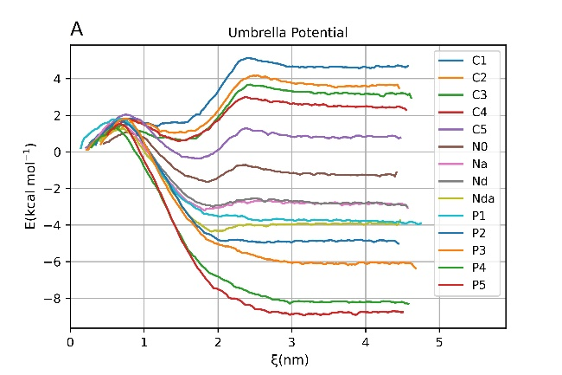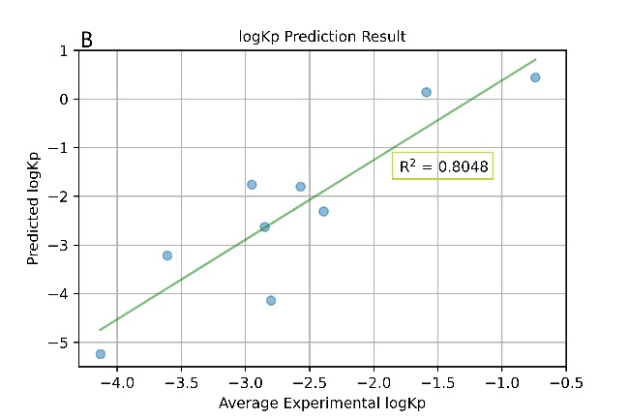
Fig. 1. A PMF profiles for 14 non-charged beads; B Comparison of experimental and predicted logKp

References
1. Hoffmann C. et al. Molecular dynamics trajectories for 630 coarse-grained drug-membrane permeations: 1 // Sci Data. Nature Publishing Group, 2020. Vol. 7, № 1. P. 1–7.
2. Vasyuchenko E.P. et al. CPE-DB: An Open Database of Chemical Penetration Enhancers: 1 // Pharmaceutics. Multidisciplinary Digital Publishing Institute, 2021. Vol. 13, № 1. P. 66.

