Does rare testate amoeba Difflugia australis (Amoebozoa: Arcellinida) or its hidden relatives live in the subtropical part of China?
Fan X.
Students, 4th year of the biology
Shenzhen MSU-BIT University, Faculty of Biology, Shenzhen, China
E-mail:1391437871@qq.com
Testate amoebae are free-living protists whose amoeboid cell is covered by an extracellular test (shell), usually with a single main opening, and which extrude lobose or filose pseudopodia. Testate amoebae are distributed worldwide and were found from the tropics to the polar regions [1,2]. They occur in most terrestrial and freshwater habitats. The presence of a shell around the amoeboid cell represents a significant evolutionary novelty. Unlike naked amoebae, testate amoebae maintain contact with the external environment primarily through the part of the protoplast that exits through one or more openings (apertures). In most cases, the size of the prey is limited by the size of the aperture. It also determines the habitats these protists inhabit - for example, due to the weight of the shell, testate amoebae relatively rarely inhabit plankton and much more often inhabit the benthos of aquatic ecosystems. The goal of our research was to characterize a new morphotype within the Difflugia australis complex that originated from a wetland on Shangchuan Island in China.
In the summer of 2022, we collected water samples from the wetland on Shangchuan Island, South China Sea, China (Fig. 1A). Morphological characteristics and morphometric variables were examined using a Zeiss Axio Imager A1 light microscope. Measurements were performed by using the AxioVision 4.9.1 program.
A good example of a rare but widespread testate amoeba is Difflugia australis. A few researchers during the 20th century, using specimens from Australia, Argentina, and Belgium, have established the following measurements: shell length 100-166 μm, shell width 57-79 μm, and aperture diameter 23-35 μm. Ndayishimiye and co-authors recorded a population of this species from Shidou Reservoir (Fujian Province, China) in 2020 and noted the following measurements: shell length 88-106 μm, shell width 53-88 μm, and aperture diameter 19-28 μm. We recorded individuals on Shangchuan Island (South China Sea, China) that were morphologically similar to typical individuals of D. australis, but smaller than previously reported: shell length 56-64 μm, shell width 34-35 μm, and aperture diameter 12-13 μm. Our individuals resemble members of the genus Pareuglypha in terms of both morphological and morphometric characters. Future studies on living individuals are necessary to determine whether our species belongs to the genus Difflugia (with lobopodia) or to the genus Pareuglypha (with filopodia). These two genera are phylogenetically very distant from each other, belonging to two supergroups of eukaryotes - Amoebozoa and Rhizaria, respectively.

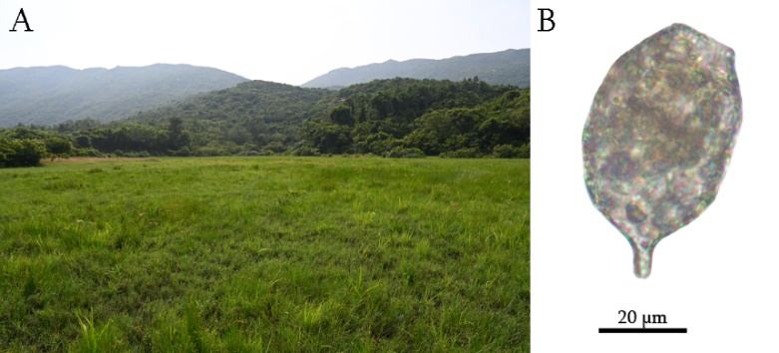
Fig. 1. A Sampling locality: a wetland on Shangchuan Island, South China Sea, China;
B A specimen of Difflugia cf. australis
References
[1] Foissner W. Protist diversity and distribution: some basic considerations // Biodiversity and Conservation. 2008. Vol. 17. S. 235-242.
[2] Wilkinson D.M. What is the upper size limit for cosmopolitan distribution in free-living microorganisms? Journal of Biogeography. 2001. Vol. 28. S. 285-291.

