Effects of marine microplastics on hard tissue of larvae of bivalves and gastropods
Guo Wenxiao,¹ Zhao Ran²
Master Student, 2th year of the Nano biotechnology
^{1,2}Shenzhen MSU-BIT University
Nano biotechnology, SMBU, China
E-mail:2120210062@smbu.edu.cn
In recent years, the prevalence of microplastics in the marine environment, which can be seriously harmful to marine organisms, has attracted increasing attention and exposed concerns about ecosystem safety(Cole et al. 2011). Currently, studies on the effects of microplastics on bivalve and gastropod marine shellfish have focused on their soft tissues such as hemolymph, gills, intestines, and feet, mainly through three pathways: uptake, adhesion, and fusion (Figure 1).(Han et al. 2022) There is also a lack of research on the effects of microplastics on hard tissues. The study of larval shell-related molecular signaling pathways under the influence of microplastic polystyrene (PS) has not been reported.
In this study, I introduced different concentrations and sizes of green fluorescent plastic microspheres PS into the larval culture system of bivalve and gastropod marine shellfish by artificial insemination(Figure 2), then I collected individuals at 6 h and 24 h after fertilization (representing the significantly observable trochophore stage and veliger stage, respectively). The enrichment of PS microplastics in the hard tissues of larvae was observed by fluorescence inverted microscopy(Figure 3), and the changes of morphological characteristics of larval shells under PS stress were observed using scanning electron microscopy(Figure 4). We examined the changes of proteomics and transcriptomics in different developmental stages under PS stress, analyzed the regulatory status of biomineralization-related gene expression, and studied the larval shell-related molecular signaling pathways.
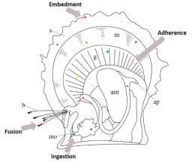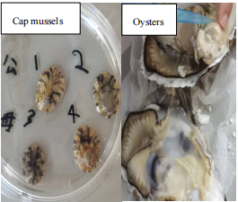
Figure 1 Schematic diagram of microplastics Figure 2 Artificial insemination experiments on
(MPs) accumulation pathways (ingestion, bivalve oysters and gastropod cap mussels
adherence, fusion, embedment) in bivalve
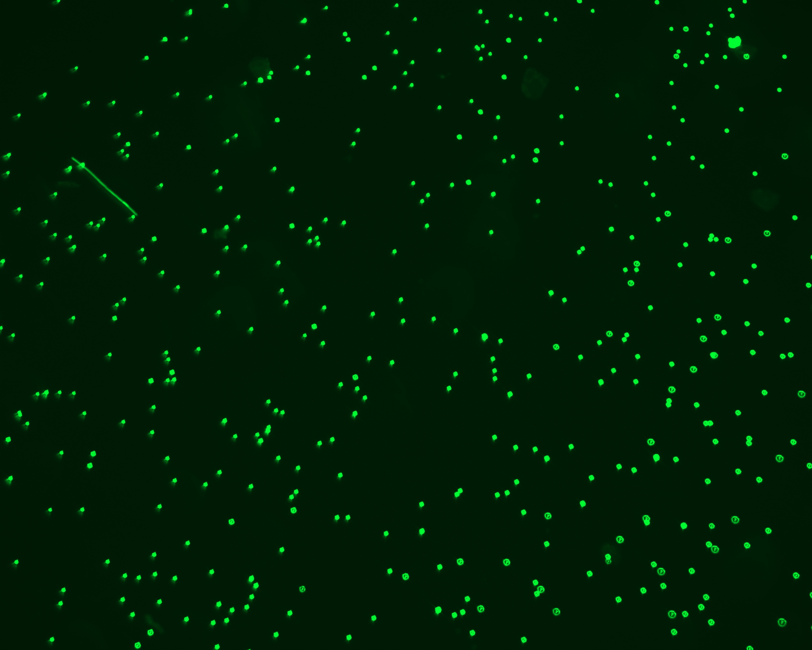
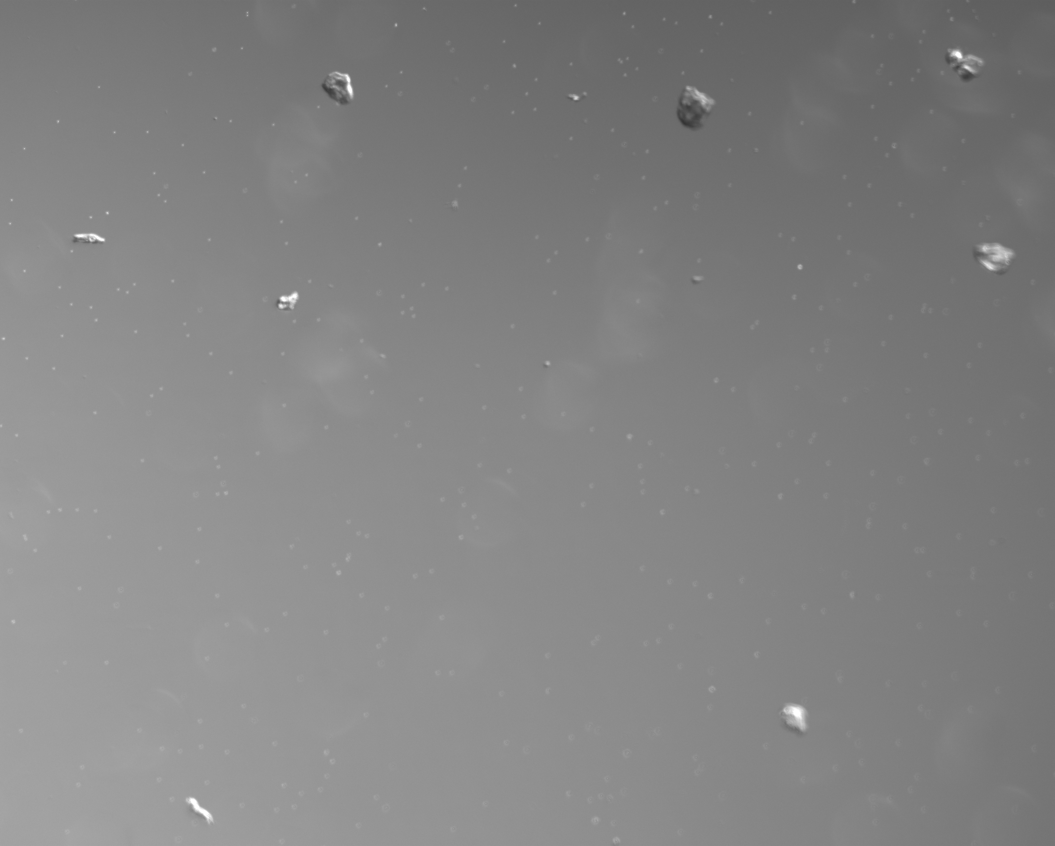
molluscs.(Han et al. 2022)
b
a
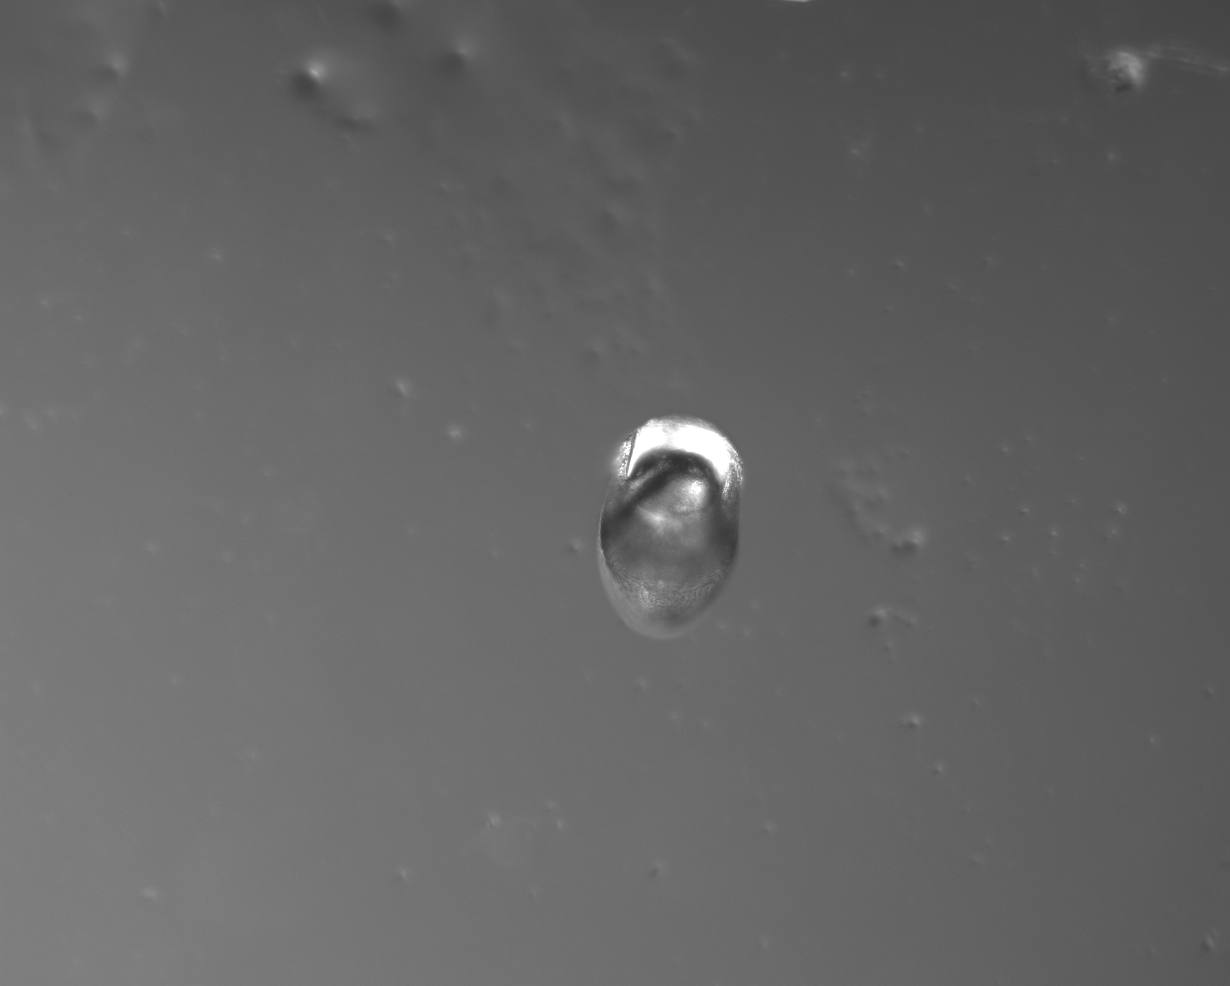
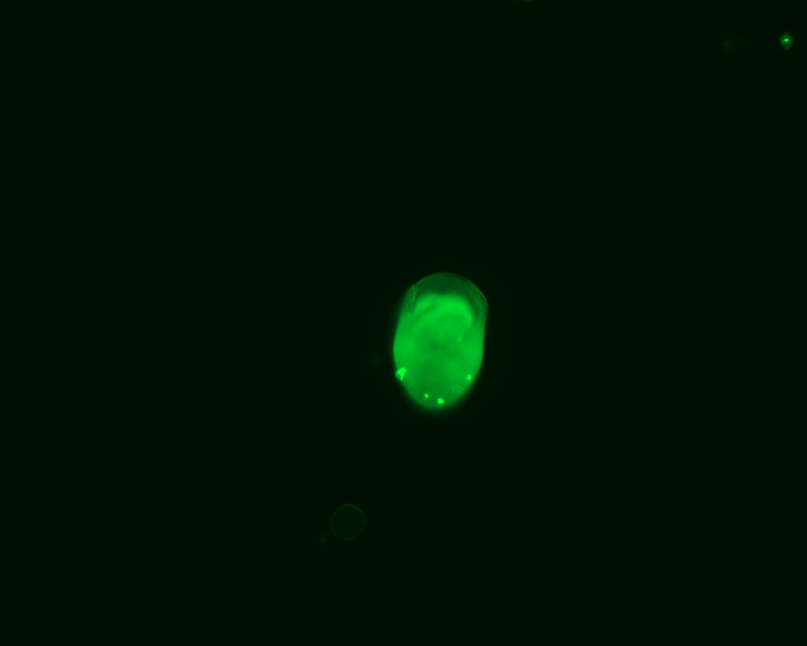
d
c

Figure 3 a.10mg/L microplastic under incandescent light microscope. b.10mg/L microplastic under fluorescence microscope excitation light wavelength 488nm. c. Incandescent light microscopy of 10mg/L microplastic on 24h veliger shell. d. Fluorescence microscopy excitation light wavelength 488nm of 10mg/L microplastic on 24h veliger shell.

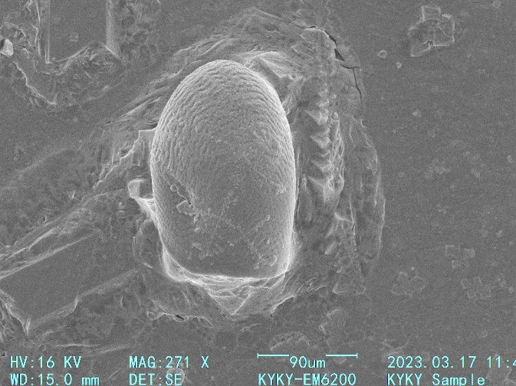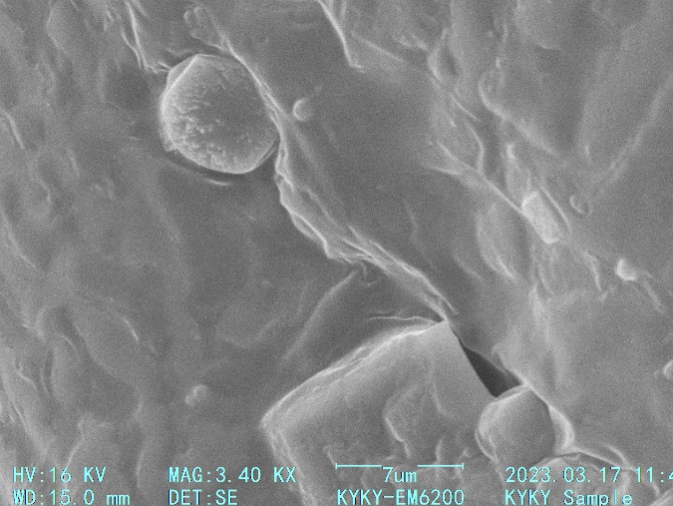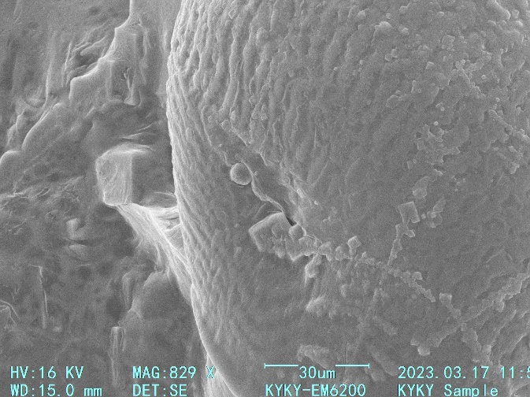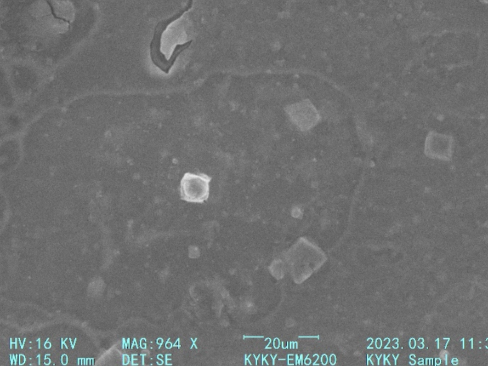
Fig. 4 Enrichment pattern of 5 μm microplastics at 10 mg/L in veliger stage shell observed by SEM.

References
[1] Cole, M., P. Lindeque, C. Halsband, and T. S. Galloway. 2011. "Microplastics as contaminants in the marine environment: A review." Marine Pollution Bulletin no. 62 (12):2588-2597. doi: 10.1016/j.marpolbul.2011.09.025.
[2] Han, Z. M., T. F. Jiang, L. P. Xie, and R. Q. Zhang. 2022. "Microplastics impact shell and pearl biomineralization of the pearl oyster Pinctada fucata." Environmental Pollution no. 293. doi: ARTN 118522
10.1016/j.envpol.2021.118522.

