**Phase-encoded quantum key distribution system over multimode communication channels**

**Vladislav Tretiakov1**

1student

MSU Quantum Technology Centre, 119991 Moscow, RussiaE–mail: tretiakov.vv18@physics.msu.ru

**Introduction**

Considering free-space quantum channels it is important to note that the implementation of polarization state protocols [1] implies quantum measurements to be conducted directly in the free-space channel, consequently the receiving telescope can not be separated from the measurement device by significant distances. However, sometimes it’s convenient to collect a signal after the receiving telescope into an optical fiber and transmit it to the place where it can be comfortably measured. Either single-mode or multi-mode optical fiber can be used for this purpose. In the first case, it’s appeared to be impractical to collect a signal into a single-mode fiber because it is distorted by the atmospheric turbulence, so a large loss level occurs. In the second case we need to refuse from polarization-state protocols because information about the polarization is lost when the signal enters a multi-mode fiber. A convenient alternative to them is a phase encoding [2]. However, commonly used delay interferometers don’t allow to obtain required interference visibility with a multi-mode signal.

**Free-space delay interferometer**

Here we investigate a multi-mode free-space delay interferometer (Fig. 1) for analyzing phase-encoded photons. Such interferometer can be used in implementation of QKD protocols based on phase encoding. The main feature of this delay interferometer is a presence of the 4fscheme in its arms, which induces the correction of the multi-mode signal's wavefront and leads to indistinguishability of two arms of the interferometer for different spatial modes. It was shown in [3] that an unbalanced delay interferometer without any additional optics does perform good enough with a multi-mode signal. Distinguishability or indistinguishability of interferometer's arms means the absence or presence of the interference visibility respectively.

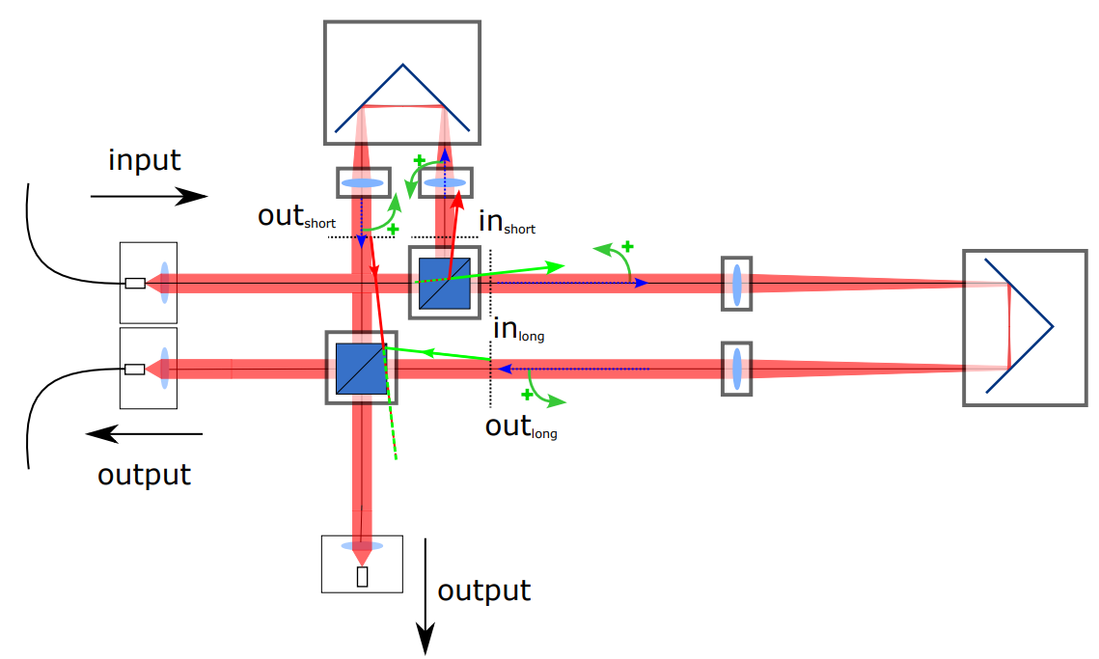

Fig. 1: Multi-mode free-space delay interferometer.

**Experimental setup**

After a series of investigations which we presented at the past International Quantum Technologies Schools in 2022 and 2023 our researches have been expanded and now we cooperate with the leading developer and manufacturer of high-tech software and hardware-based information security tools - InfoTeCS company. The main purpose of our current work is to develop a system's prototype suitable for QKD over free space channels up to 2 km. This system should be based on the existing commertially available QKD system, developed by the InfoTeCS company and applied for QKD over optical fiber channels. The schematic of the experimental setup is depicted in the Fig. 2.

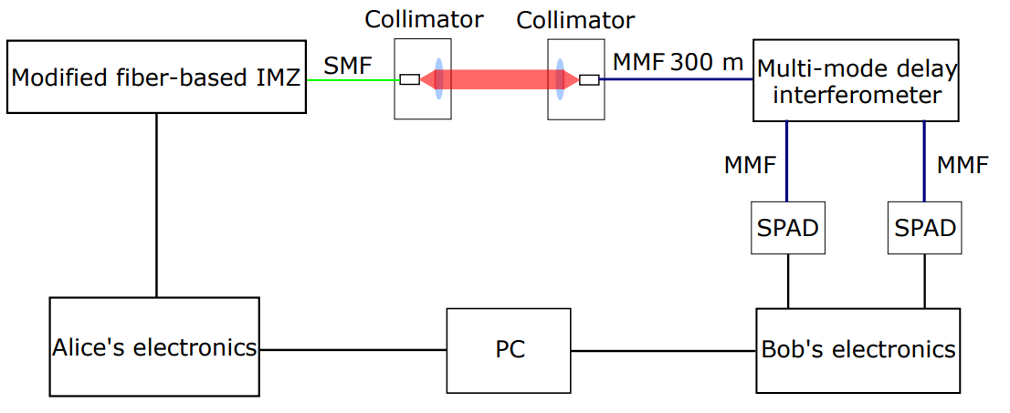

Fig. 2: The schematic of the experimental setup.

As it was mentioned in the previous section, our intention is to develop a QKD system's prototype based on the QKD InfoTeCS system with minimal modifications, so basically except for some minor details we have replaced Bob's fiber delay interferometer with the free-space multi-mode delay interferometer and the fiber optic link with a free-space channel. Then we have conducted a QKD experiment in the laboratory environment, and observed a quantum bit error ratio with a mean value of 4.93% and a standard deviation of 1.49%.

**Conclusion**

We have developed the laboratory quantum cryptography system suitable for QKD over free-space channels based on the existing commertially available QKD system developed by InfoTeCS company. We obtained a satisfactory value of QBER which is small enough and allowed us to obtain a secret key. Nevertheless the stability of the system is not perfect, so the our following researches will be devoted to its enhancement as well as to the development of the non-laboratory prototype of this system over the free-space channel up to 2 km.

**References**

[1] Hideki Takenaka, Alberto Carrasco-Casado, Mikio Fujiwara, Mitsuo Kitamura, Masahide Sasaki,and Morio Toyoshima. Satellite-to-ground quantum-limited communication using a 50-kg-class microsatellite. NaturePhotonics, 11(8):502– 508, jul 2017.

[2] Xiao-Tian Song, Dong Wang, Xiao-Ming Lu, Da-Jun Huang, Di Jiang, Li-Xian Li, Xi Fang, Yi-Bo Zhao, and Liang-Jiang Zhou. Phase-coding quantum-keydistribution system based on sagnac–mach-zehnder interferometers. Phys. Rev. A, 101:032319, Mar 2020.

[3] Jeongwan Jin, Sascha Agne, Jean-Philippe Bourgoin, Yanbao Zhang, Norbert Lutkenhaus, and Thomas Jennewein. Demonstration of analyzers for multimode photonic time-bin qubits. Phys. Rev. A, 97:043847, Apr 2018.