**A Scalable, Error-Tolerant, Reprogrammable Architecture for Integrated Linear-Optical Light Conversion**

***Fldzhyan S.A.1,2*, *Saygin M.Yu.1, Kulik S.P.1,3, Straupe S.S.1,2***

student,

1Quantum Technologies Center, M.V. Lomonosov Moscow State University, Moscow, Russia

2Russian Quantum Center, Moscow, Russia

3Laboratory of quantum engineering of light, South Ural State University, Chelyabinsk, RussiaE–mail: apres.suren@gmail.com

The integrated interferometers, composed of beamsplitter and phaseshifter arrays, can inherently realize the conversion of N input channels to N output ones described by a unitary matrix. This interferometer may consist of L = N + 1 phase-shifter layers, with some beamsplitter arrangements in between 1. To achieve a general light conversion governed by a non-unitary NxN matrix, traditionally the SVD technique is employed. The target matrix S is decomposed into S = VDU, where V and U are unitary matrices and D is a diagonal matrix of positive coefficients. V and U are realized trivially, and D is realized through reconfigurable amplitude damping, for example, using a MZI interferometer.

Recently, a new technique shown in Figure 1a) was proposed that significantly reduces the size of embedded interferometers 2. Instead of the traditional SVD technique, which requires L = 2N + 3 reconfigurable phaseshifter layers, the new technique only requires L = N + 2 phaseshifter layers. The key aspect of this new proposal is to widen the interferometer. To achieve the general conversion of N input channels to N output ones, M = 2N channels are required. N input channels are distributed into M channel interferometer, and only N of M channels at the output are considered.

However, the authors of 2 suggest the use of long-depth and prone to fabrication errors mixing layers. These include multimode interference couplers and multiport directional couplers, each of which grows in depth and complexity as the size of the S matrix increases. Therefore, it would be advantageous to find a mixing layer that does not become increasingly complex as the matrix size increases. Our proposal is to employ a simpler constant-depth mixing layer schematically shown in Figure 1b), similar to the one previously described in 3. This error-tolerant mixing layer consists only of beamsplitters in the form of directional couplers. We demonstrate that the proposed mixing layer inherits error-tolerance.

As there is no analytical procedure for obtaining phaseshifter values given the S matrix, we derived an iterative procedure that minimizes the normalized squared error measure of the target matrix and the realized matrix. The results of this iterative decomposition procedure are depicted in Figure 1c). We can clearly observe the plateau of error-tolerance.

S.A.F., M.Yu.S. and S.S.S. are grateful to the Russian Roadmap on Quantum Computing for support. S.A.F. is grateful to the Foundation for the Advancement of Theoretical Physics and Mathematics (BASIS) (project No. 23-2-10-15-1).

References

1: B. A. Bell, I. A. Walmsley, "Further compactifying linear optical unitaries", APL Photonics 6(7), 070804 (2021), <https://doi.org/10.1063/5.0053421>

2: Tang, R., Tanomura, R., Tanemura, T., & Nakano, Y., "Lower-depth programmable linear optical processors", Phys. Rev. Applied 21(1), 014054 (2024), <https://doi.org/10.1103/PhysRevApplied.21.014054>

3: Fldzhyan, S. A. and Saygin, M. Yu. and Kulik, S. P., "Optimal design of error-tolerant reprogrammable multiport interferometers", Optics Letters 45(9), 2632 (2020), <https://doi.org/10.1364/ol.385433>

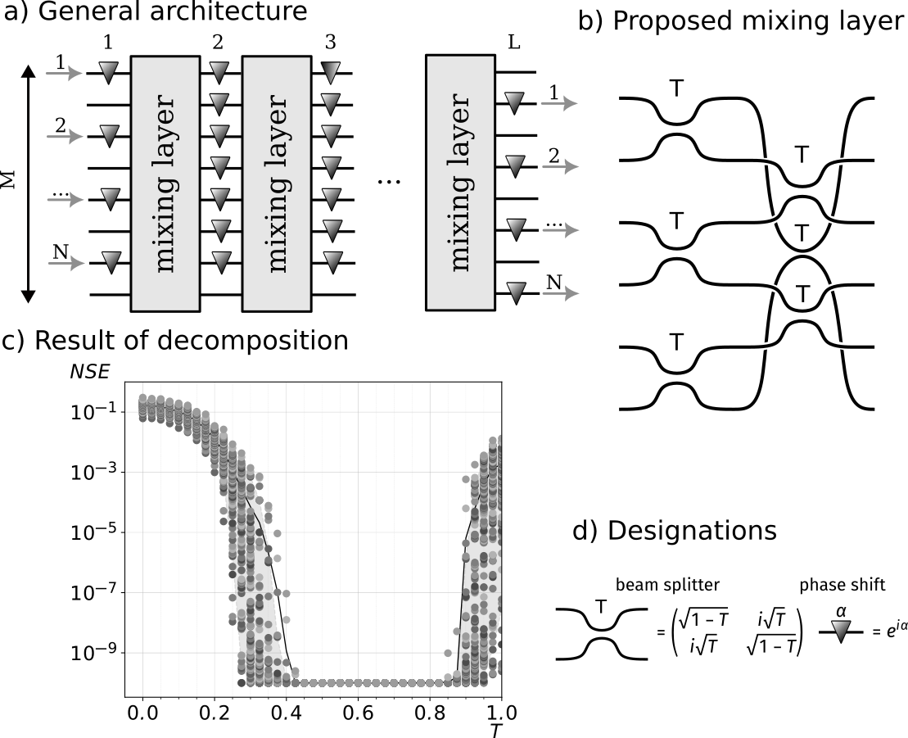**Figure** **1:** a) General architecture for the decomposition of any NxN matrix S. b) Exhibiting error-tolerance, constant-depth mixing layer proposed in this work. This periodic at the edges structure may be realized using integrated optics methods. c) Results of the decomposition algorithm. NSE is the normalized squared error of the target S and realized S. Each dot is one of 100 random matrices, solid line is mean, shaded are contains 90% of dots. d) Designations on the figure.