**Synthesis of Functionally Substituted Cyclopropane Carboxylic Acids: Design** **of New Ethylene Biosynthesis Inhibitors and *In Silico* Investigation of Their Activity**

***Bagdasaryan S.A.1,2, Grigoryan A.M.1,2, Sahradyan M.G.1, Mikaelyan A.R.2***

*Postgraduate student, I year of study*

*1Russian-Armenian State University, Yerevan, Armenia*

*2Armenian National Agrarian University, Yerevan, Armenia*

*E-mail:* [*sambagd55@gmail.com*](mailto:sambagd55@gmail.com)

Ethylene is an important plant hormone that plays a crucial role in its various physiological processes. It impacts on a broad spectrum of plant growth and developmental stages, encompassing germination, senescence and abscission of leaves and flowers, cell elongation, fruit ripening, nodulation, and the response to a diverse range of stresses [1].

Ethylene is derived from the methionine through a series of reactions [2]. Methionine converts to S-adenosylmethionine, which transforms into 1-aminocyclopropane-1-carboxylic acid (ACC) by ACC synthase. Finally, ACC is converted to ethylene by ACC oxidase (ACO).

Structural analogues of ACC have been proved to have an inhibitory effect on the ethylene production. Our laboratory proposed a technologically easily feasible method of synthesis of functionally substituted ACCs. The generalized scheme includes of ATRA trihaloacetic acid derivatives to unsaturated substrates (terminal olefins) and dehalogenation-cyclopropanation of the resulting 1,3-dihalides with Zn/Cu pair or other metals (Fig. 1) [3].

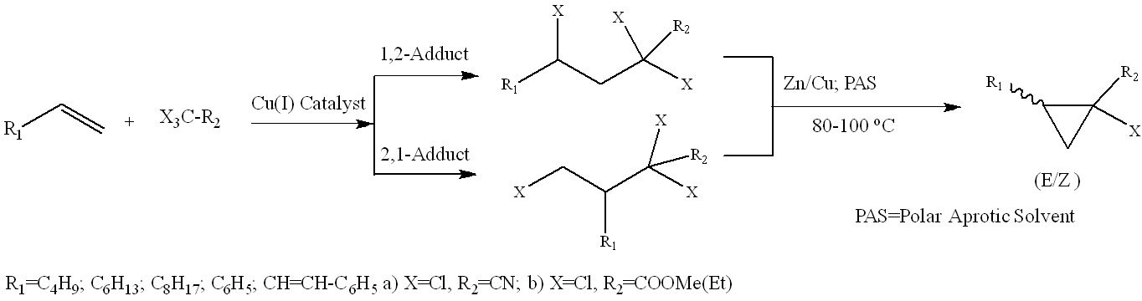

Figure 1. The general scheme of synthetic transformations

In current research we developed highly efficient catalytic system [Cu(I) Catalyst: 1) CuBr - 10 mol% to substrate, 2) secondary ammine, 3) catalytic co-ligand/solvent – DMSO․ Molar ratio1):2):3) = 1:1:7-10], reaction time: 1.5h, adducts yield: 95%.

In addition, we conducted a docking study of ethylene biosynthesis inhibitory activity for newly synthesized (*E*)-2-phenyl-1-chlorocyclopropane-1-carboxylic acid (*1R,2S* and *1S,2R* isoforms) in comparison to commercially applicable methylcyclopropane and natural inhibitor pyrazinoic acid on ACO2(*Arabidopsis thaliana)* (Table 1).

Table 1. Docking results

|  |  |  |  |  |
| --- | --- | --- | --- | --- |
| Ligand | Methylcyclopropane | Pyrazinoic acid | *1R,2S* | *1S,2R* |
| Affinity | -3.1 | -5.3 | -6.0 | -6.2 |
| Binding sites | Leu189  (Phe36, Ala251 / Leu198, Arg247, Ser249) | Leu189, Leu177, Arg247, Ser249, Lys161, His180, His237  (Leu198) | Leu189, Leu198, Ser249, Ser163, Tyr165, Val239, Lys161, Ala251, Asn219, Ile187, Phe253 His237 | Leu189, Leu198, Leu177, Ser249, Ser163, Tyr165, Val239, Lys161, Ala251, Ile187, Phe36, His237 |

**Literature**

1. Hormone Metabolism and Signaling in Plants. 1st Ed. / ed. Li J., Li C., Smith S. Beijing, CN: Academic Press, 2017.

2. Argueso C.T., Hansen M., Kieber J.J. Regulation of Ethylene Biosynthesis // J Plant Growth Regul. 2007. Vol. 26. P. 92–105.

3. Karapetyan H.A., Tamazyan R., Mikaelyan A.R., Raganyan N.P. X-Ray Investigation of (E)-2-phenyl-1-chlorocyclopropane-1-carboxylic Acid — A Convenient Synthon for Transamine Synthesis. 2004. Vol. 45(2). P. 352-255.