**Zeolitic imidazolate framework-8 membrane for lithium extraction**

**Doroshenko I.V. *1***, **Dmitrieva M.A. *1***, **Filippova I.S. *1*, Krivoshapkina E.F. *1***

*Student, 1 year of master’s degree*

*1ITMO university, ChemBio cluster, SCAMT institute, St. Petersburg, Russia*

*E-mail:* [*doroshenko@scamt-itmo.ru*](mailto:doroshenko@scamt-itmo.ru)

**Introduction.** The demand for lithium, known as the "Energy Metal in the 21st Century" [1], is continuously growing due to the increased usage of electric-powered vehicles and advanced electronics operating on lithium-ion batteries. Global lithium demand is increasing significantly, and it is expected to become scarce. That is the main reason for an emphasis to be made on recapturing waste and converting it into a raw material, increasing the metal’s availability and making lithium production more sustainable. Direct lithium extraction technologies show a potential in increasing the supply of lithium from water projects, including operations with enriched by lithium waste waters of oil and gas condensate fields.

**Body part of the report summary.** The idea of the project is to extract lithium with the membrane technology, using this membrane as an extractor module. Technology will allow oil producing companies to get additional profit from the waters of oil and gas condensate fields.

The multi-layer composite membrane is based on cellulose acetate and is modified with a metal-organic framework zeolitic imidazolate framework-8 (ZIF-8). Cellulose acetate (CA) can be described as an affordable carrier material for metal-organic framework structures with a good stability during the metal-extraction process [2]. A choice of ZIF-8 for ion-selective separation was made due to its homogeneous porosity, specific size characteristics, and substantial surface areas, allowing this framework to be highly suitable for lithium recovery applications [3]. The calculations showed that about 38% of ZIF-8 from the precursor solution binds to the membrane surface. Fig. 1 represents Scanning electron microscopy (SEM) and Energy-dispersive X-ray spectroscopy (EDX) results of the membrane analysis. The results indicate the successful synthesis process, demonstrating the presence of ZIF-8 on the surface of the membrane.

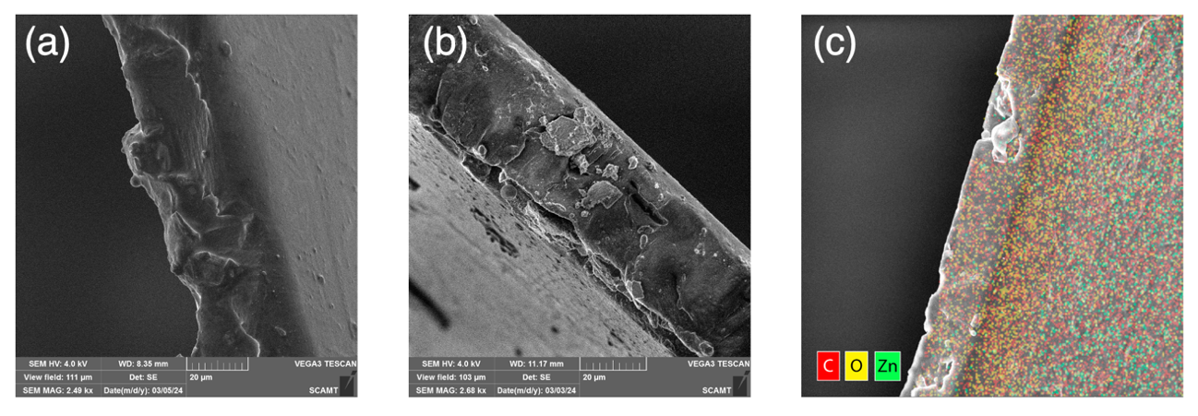

Fig. 1. (a) SEM for CA; (b) SEM for CA with a ZIF-8 layer;   
(c) EDX for CA with a ZIF-8 layer

**Conclusions.** A comprehensive analysis of lithium extraction methods was conducted, and the results of this analysis led the research towards choosing the ion-selective membrane as the most promising technology for lithium extraction from oilfield waters. Afterwards, the most promising practically-applicable modifications of the membrane have been researched.

*The work was supported by state assignment No. FSER-2022-0002 within the framework of the national project “Science and Universities”.*

**References**

1. Garcia L. V. *et al.,* “Lithium in a Sustainable Circular Economy: A Comprehensive Review,” Processes, vol. 11, no. 2, p. 418, Jan. 2023.
2. Paredes C. *et al.,* “Selective lithium extraction and concentration from diluted alkaline aqueous media by a polymer inclusion membrane and application to seawater,” *Desalination*, vol. 487, p. 114500, Aug. 2020.
3. Yu H. *et al.*, “Selective lithium extraction from diluted binary solutions using   
   MOF-based membrane capacitive deionization,” *Desalination*, vol. 556, p. 116569, Jun. 2023.