**Localization Algorithms in Advertising**

Бенгханну Надия Мохамедовна

Студентка Санкт-Петербургского государственного университета, Санкт-Петербург, Россия

Localization is a multilevel process that involves three major fields: cultural adaptation, language translation and content customization. Translation is considered a central and essential component of localization process [O’Hagan: 39; Altanero: 32; Bravo, Enríquez: 57; Efimova: 192]. Still, mere translation is just the first step and the surface level of localization. To meet the expectations of the target audience the source text has to be adapted to make the product “linguistically and culturally appropriate to the target locale (country region and language) where it will be used and sold” [Esselink 2000:3]. Adaptation in its essence means recreation, and as a creative process it seems to confront with the algorithmization of any kind. Nevertheless, localization is an integral part of contemporary marketing, and as one it demands planning which in turn requires certain algorithm.

It is not once that attempts to algorithmize localization were made. LISA, the Localization Industry Standards Association, established in 1990, focuses on localization industry standards and is now the heavyweight in the field. Currently LISA includes Directorate-General for Translation of the European Commission, Adobe Systems, Hewlett-Packard, Cisco Systems, LionBridge, Lessius Hogeschool, SDL International, World Bank Group, Nokia Corporation. Alongside with LISA GALA, The Globalization and Localization Association provides services for the localization industry. The list can be replenished with the Localization Institute, Localization World, Localization Research Centre (LRC) and TiLP, the Institute of Localization Professionals. These organizations offer certification and organize trainings.

However, they contribute very little to filling the niche of algorithmization. As practice-oriented as localization is, translation studies within localization industry, though the essence of it, are mostly left aside.

This is the cause for our attempt to develop the algorithm for localization process. In this paper we concentrate on advertising, but later the principles can be expanded to cover various branches of localization. To simplify the explanation we use the following chart.

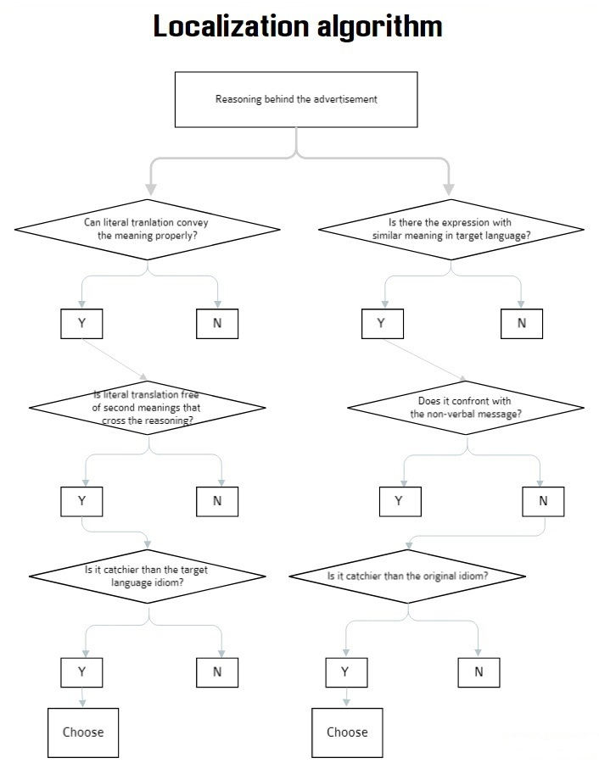

The chart above is general version, but the detailed one is supposed to be the base of the code for professional software. Referring to the databases of online dictionaries, on one hand, and to the statistic, on the other, this software will hopefully make localization process less consuming when it comes to energy and time.

**Литература**

Altanero T. The localization job market in academe // Translation Technology and its Teaching. 2006. P.31–39.

Bravo C., Enríquez V. Summary of discussion on Localization and Translator Training // Translation Technology and its Teaching. 2006. P.55–59.

Efimova V.V. Localization as a modern branch of applied translation studies // Problems of language and translation in young scientists’ research: collected works. 2016. № 16, Р.188–192.

Esselink B. A Practical Guide to Localization. Amsterdam/Philadelphia, 2000.

O’Hagan M. Training for localization (replies to a questionnaire) // Translation Technology and its Teaching. 2006. P.39–45.