“ESG: TRANSFORMING BUSINESS FOR A SUSTAINABLE FUTURE IN THE ERA OF GLOBAL CHANGE”
Bocharova Vita
Supervisor: Berberova Liana Burkhanovna
¹Financial University, Russia, vitabocharova988@mail.ru

Abstract. This article explores the importance of adopting the ESG-strategy to promote the long-term sustainability of businesses amidst global changes. It emphasizes the need for companies to integrate ESG principles into their operations, considering both financial and legal aspects. By incorporating ESG factors, businesses can effectively address environmental challenges, social issues, and governance concerns, ultimately leading to improved financial performance and risk management. The article highlights how ESG practices can enhance a company's reputation, attract investors, and meet the evolving expectations of stakeholders. Additionally, it discusses Legal risks and rewards. Companies that do not pay proper attention to ESG factors may face legal risks, such as lawsuits or fines for violating environmental or labor laws.
Keywords: ESG-strategy, sustainable development, environmental and social initiatives, carbon footprint, greenhouse gas emissions, Paris agreement.

ESG (Environmental, Social, and Governance) agenda plays a significant role in its implementation in business. As current practice shows, the faster companies get on the ESG track, the less likely they are to face problems in finding investors and sometimes even their potential customers. Therefore, when talking about ESG strategy, it is necessary to consider not only through the prism of financial aspects but also to pay attention to the legal basis of companies and corporations. ESG strategy plays a key role in achieving sustainable development and increasing the investment potential of business. That is why more and more companies nowadays are switching to ESG practices and integrating them into their activities, realizing that this is not only a way to create a positive social and environmental image but also an effective tool for attracting investments and increasing competitiveness.
Business today is directly dependent on the state and its policies. Within the framework of the UN Framework Convention on Climate Change on December 12, 2015, 197 countries signed the Paris Agreement, the main goal of which is to avoid a rise in Earth's temperature. Therefore, states will give advantages to those enterprises and companies that have switched to the ESG track. These advantages currently include special lending conditions: now, ⅓ of Russian banks adhere to the ESG strategy, and 20% of the rest are considering the transition to it. For example, SBER issues loans that depend on the dynamics of sustainable development indicators. And those whose activities will carry a significant carbon footprint and will not try to reduce it will be burdened with a carbon tax and other stimulating measures.
One of the main advantages of the ESG strategy is attracting investments. Modern investors are increasingly focusing on ESG factors when making investment decisions. Companies that implement ESG practices in their activities can attract more investment and obtain credit at lower rates. Investors, investing their money, rely on the legal basis dependent on state policy, therefore they strive to invest in companies that show social and environmental initiatives, aiming for the long-term success of the company, which is measured by the presence of ESG strategies.
However, when implementing an ESG strategy, there are risks of encountering certain problems related to ESG business reporting. Companies must provide information about their ESG indicators, include it in financial reporting, so the absence of unified standards, lack of proper control over all levels of the carbon footprint can make it difficult to compare and analyze data.
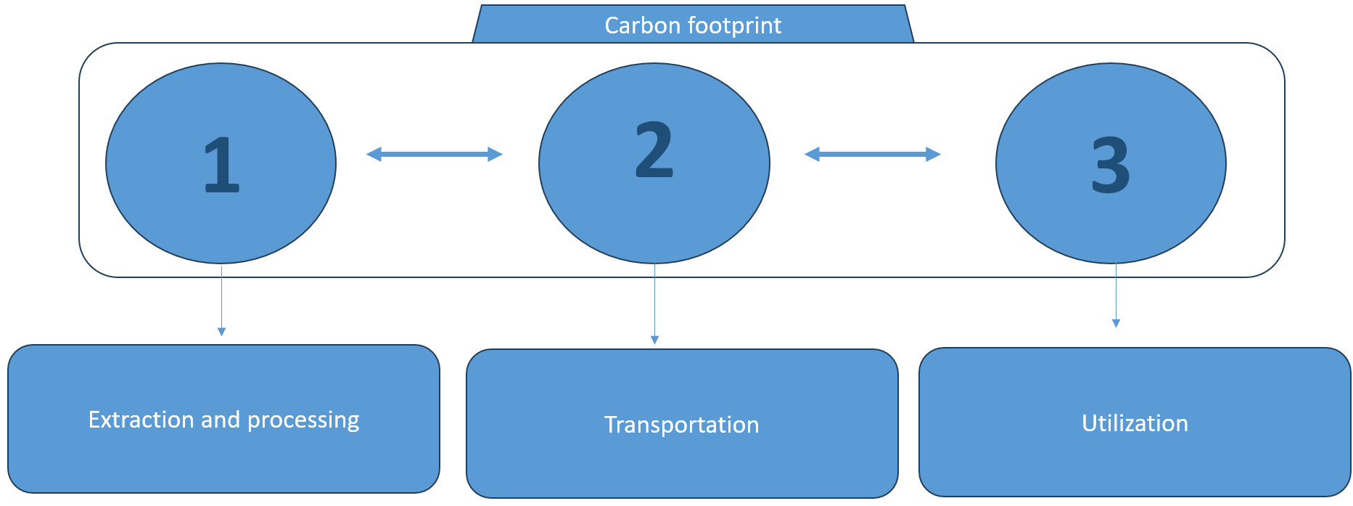
Figure 1. Carbon Footprint Levels
The highest indicator of the carbon footprint at the moment is the fuel and energy complex enterprises.
 | 2005 | 2010 | 2012 | 2013 | 2014 | 2015 | 2016 | 2017 | 2018 | 2019 | 2020 | 2021
Energy Industry | 1590,2 | 1639,3 | 1694,5 | 1625,2 | 1617,1 | 1611,3 | 1606,1 | 1637,0 | 1688,7 | 1682,3 | 1594,1 | 1679,1
Industrial Processes | 212,4 | 204,4 | 223,9 | 229,2 | 230,0 | 228,0 | 228,2 | 243,0 | 252,3 | 246,3 | 254,4 | 259,5
Agriculture | 106,8 | 105,4 | 107,1 | 109,6 | 109,4 | 110,5 | 114,3 | 115,2 | 114,8 | 116,4 | 118,8 | 121,3
Land Use | -539,7 | -698,1 | -661,5 | -612,6 | -657,4 | -583,3 | -615,3 | -602,9 | -577,3 | -550,5 | -557,6 | -484,8
Waste | 61,2 | 70,3 | 75,4 | 77,8 | 81,1 | 83,4 | 85,5 | 87,5 | 89,5 | 91,4 | 94,1 | 96,7

Table 1. - Greenhouse Gas Emissions by Sector (million tons of CO2 equivalent per year)
It should be noted that now the calculation of the carbon footprint within the ESG is calculated only at the first level, that is, not even affecting the transportation stage. This encourages the state to increase transparency and consistency in full ESG reporting. However, transparency and reliability of reporting can be weakened by subjectivism in the assessments. Therefore, regulators, that is, the states, must strive to develop unified standards and methodologies for assessing ESG indicators in order to reduce subjectivism and enhance trust in sustainability indicators. Modernizing legislation in the context of introducing additional levels of carbon footprint into the ESG coefficient would help improve the quality of ESG calculation.
Thus, legal aspects are an important component of the ESG strategy. Many countries and international organizations implement legal mechanisms to promote and regulate ESG practices. These are both requirements for ESG reporting and sustainability and social responsibility standards, as well as sanctions for violating these standards. Companies that do not pay due attention to ESG factors may face legal risks such as lawsuits or fines for violating environmental or workers' rights legislation. On the other hand, companies that successfully integrate ESG practices may gain competitive advantages and benefits such as tax incentives or access to state financial grants.
The ESG strategy becomes a necessity for businesses striving for sustainable development and wanting to maintain their profitability and competitiveness in a changing world. The integration of ESG practices allows companies to attract investments, increase their competitiveness and efficiency, and take into account social and environmental aspects in their activities. However, for the successful implementation of the ESG strategy, cooperation between companies, investors, regulators, and other stakeholders is necessary, as well as the development of unified standards and methodologies for assessing ESG indicators for systematized accounting.

REFERENCES
- Баторшина, Г.Д. ESG — стратегии российских компаний в современных условиях / Г.Д. Баторшина // Экономика образования. — 2022. — № 3(130). — С. 81–90. — EDN IMJHRY
- Макаров И.Н. ESG повестка как фактор конкурентоспособности бизнеса и регионов в контексте устойчивого развития // У – 2021. - №24. – с. 26-37
- Ефимова О.В., Волков М.А., Королёва Д.А. Анализ влияния принципов ESG на доходность активов: эмпирическое исследование. Финансы: теория и практика. 2021;25(4):82–97. DOI: 10.26794/2587–5671–2021–25–4– 82–97

