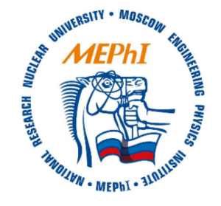

Third International Summer School on ENGINEERING COMPUTING IN NUCLEAR TECHNOLOGIES
2 – 13 July 2018
MEPhI, Moscow, Russia
ORGANIZERS
- MEPhI
- TESIS
- FIDESYS
- MCU
- Star-net
- Western Norway University of Applied Sciences
REGISTRATION
1 March – 6 April, 2018

NOTIFICATION
till 25 April, 2018

DURATION
2 – 13 July, 2018

WEBSITE
http://confer.mephi.ru/eng/event/4869/

CONTACTS
Georgy Tikhomirov, deputy director, Institute of Nuclear Physics and Engineering, National Research Nuclear University “MEPhI”
31 Kashirskoe Shosse, 115409, Moscow, Russia

EMAIL
GVTikhomirov@mephi.ru
ALFarkhulina@mephi.ru

TELEPHONE
+7 495 788 56 99 (ext. 9364)
+7 925 380 62 57 (mobile)

The school on engineering computing in nuclear technologies is a certificate course aiming to provide specialized education and training on mathematical modeling of physical processes. It also addresses the issue of multiple simultaneous physical phenomena modeling (Multiphysics). The course introduces modern engineering codes: MCU, FlowVision, Fidesys, Star CCM+ and focuses on the application of the programs for various problems of different complexity. The culmination of the School is solution of the Multiphysics problem (neutronics - thermal hydraulics - thermal mechanics).

School structure: First week – one theoretical session and four sessions of programs (MCU, FlowVision, Fidesys, Star CCM+). Second week – training and exercises with consultations (addressing the Multiphysics problem).

Engineering codes: CFD codes FlowVision and Star CCM+ deal with issues of aero- and hydrodynamics. CAE-system Fidesys is aimed to perform analysis of firmness. MCU – modelling of radiation transport (neutrons, gamma radiation, electrons, positrons) in three-dimensional media with the use of Monte-Carlo method.

Participants: Young professionals, postgraduates (master’s and doctoral students) from nuclear field or/and involved in computer modeling of physical processes (under 35 years old).
Working language: English.

Participation is free of charge.
Please apply through the website!

