The main thematic
directions of the conference:

1. Faculty of agronomy and biotechnology. Genetics, selection and biotechnology. Agronomy.
2. Faculty of zootechny and biology. Modern technologies in cattle breeding.
3. Faculty of horticulture and landscape architecture. Topical issues of gardening and landscape architecture
4. Faculty of Soil Science, Agrochemistry and Ecology. Soil science, agrochemistry, melioration and forestry. Agroecology and ecology of nature management. Microbiology.
5. Humanities and Pedagogical Faculty. Actual problems of the humanities. Foreign language in the professional sphere and linguistics.
6. Technological Faculty. Topical issues of food technology and quality management.
7. Institute of Economics and Management of the AIC. Actual issues of the economy. Modern problems of management in the agroindustrial complex. Modern problems of accounting and analytical management of the agro-industrial complex. Business statistics.
8. Institute of Mechanics and Energy named after V.P. Goryachkina. The scientific heritage of Academician V.P. Goryachkina.
9. Institute of Land Reclamation, Water Resources and Construction named after A.N. Kostyakov.
Actual issues of environmental management and water use.
Conference languages: Russian and English
University address: 127550, Moscow, Timiryazevskaya Str. 49
Directions: Art. Metro "Savelovskaya" - buses 72, 87; Art. metro station "Timiryazevskaya", "Dmitrovskaya" - tram 27 to the stop "Agrarian University"

Conference Organizing Committee:
Vice-rector for scientific work - Belopukhov Sergey Leonidovich
Engineer of the department of organization and planning of NID: Viktoria Bober
+7 (906) 791-82-30, vbober@rgau-msha.ru
Chairman of the SMU: Mishunov Rishat Anatolievich +7 (917) 526-77-84, migunovrishat@mail.ru
Faculty of Agronomy and Biotechnology:
Rima Norakovna Kirakosyan,
+7 (985) 460-66-65, smu.agro.bio@gmail.com
Faculty of zootechny and biology:
Viktor Malorodov
+7 (906) 838-00-57, ptitsa@rgau-msha.ru
Faculty of Horticulture and Landscape Architecture: Baidina Anastasia Vasilyevna
+7 (909) 666-45-21, luna-mars@bk.ru
Faculty of Soil Science, Agrochemistry and Ecology: Tikhonova Maria Vasilievna,
+7 (916) 841-39-52, tikhonova112@mail.ru
Faculty of Humanities and Education:
Kotusov Dmitry Vyacheslavovich
+7 (916) 215-83-80, dentor@ya.ru
Technological Faculty:
Robkova Tatyana Olegovna,
+7 (906) 744-00-37, gvuenhwyvar@mail.ru
Institute of Economics and Management of Agroindustrial Complex:
Malyha Ekaterina Fedorovna
+7 (499) 976-33-24, nauka-ef@mail.ru
Institute of Mechanics and Energy named after V.P. Goryachkin: Romanenkova Maria Sergeevna
+7 (953) 331-53-29, mashkaromanenkova@mail.ru
Institute of Land Reclamation, Water Resources and Construction named after A.N. Kostyakov:
Gornostaev Vladislav Igorevich
+7 (916) 482-69-73, vgornostaev@rgau-msha.ru

MINISTRY OF AGRICULTURAL HOSPITAL
RUSSIAN FEDERATION
RUSSIAN STATE
AGRARIAN UNIVERSITY -
Moscow Agricultural Academy named after K.A. TIMIRYAZEVA

THE COUNCIL OF YOUNG SCIENTISTS
RGAU-MAAA named after K.A. TIMIRYAZEVA

INFORMATION
LETTER

International scientific
conference of young scientists and specialists dedicated to the 150th anniversary of the birth of V.P. Goryachkina

5-6 June 2018

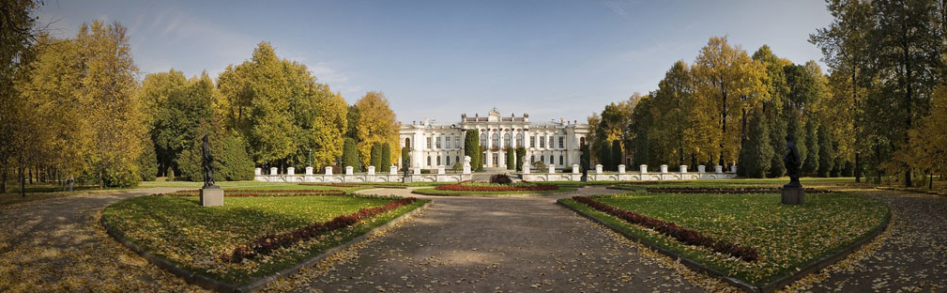

MOSCOW - 2018
DEAR COLLEAGUES!
We invite you to take part in the International Scientific Conference of Young Scientists and Specialists dedicated to the 150th anniversary of the birth of V.P. Goryachkina
The terms of participation:
The conference will be held on June 5-6, 2018 at the RASU-MAAA named after K.A. Timiryazev.
Forms of participation in the conference: full-time.
The conference is attended by graduate students, researchers, young scientists and teachers under the age of 35 years.
The articles are accepted for publication at the condition of full-time speech at the conference.
The order of submission of abstracts:
Registration of applications and submission of articles from April 17 to May 22, 2018 on the Youth Scientific Portal "Lomonosov" on the conference page http://lomonosov-msu.ru/eng/event/3697/ (electronic registration only).
It is necessary to register on the portal "Lomonosov" http://www.lomonosov-msu.ru, in your profile click "Calendar" (on the left) and through the "Search query" find the page of the scientific conference of young scientists and specialists, click " Submit an application ", fill in the online application form and attach the file with the theses.
Applications received by mail or by electronic mail (e-mail) are not considered and are not registered.
Participation in the conference is free of charge.
Payment for accommodation and meals for non-resident participants of the conference is made at the expense of travel expenses of the sending party.

Requirements for registration
materials:

Articles are accepted for publication up to 5 A4 pages (210 × 297 mm), including tables (no more than 2) and drawings (no more than 2), bibliographic list (no more than 5 sources, not older than 10 years).
The text must be typed on the computer in the Word for Windows editor in Russian or English. Page margins - 2 cm from all sides. Font Times New Roman, the main font size is 14 pt, in tables - 12 pt. The line spacing is 1.0, the indentation is the same - 1.25 cm.
Left without paragraph UDC or BBK, title of the article (centered without paragraph indentation), missing line - name, course, faculty (institution), organization, e-mail, then the missing line - abstract to the article (no more than 5 lines), missed string - keywords (3-5 words).
Tables are numbered if there are more than one. The text should contain a reference to the tables. When you create tables in the upper right corner, write the word table with the number (table 1), then the thematic heading to the table (in the center, without a paragraph indentation). Drawings and graphics in JPG format, the use of flow charts is not allowed. The name of the illusion (figure, graph) is placed under it, and if more than one illustration is used, it is numbered (Figure 1). The text captions align in the center without a paragraph indentation.
The bibliographic list is made in accordance with GOST 7.1.-2003, the text of the article should refer to the literature used (in square brackets).
The author is responsible for the content of the article (the accuracy of citations, facts, statistics).

The Organizing Committee has the right to refuse from participation in the conference reports received after May 22, or submitted in violation of the requirements.

Based on the materials of the conference, a collection of thematic articles will be published.

A sample of the article is available here:

