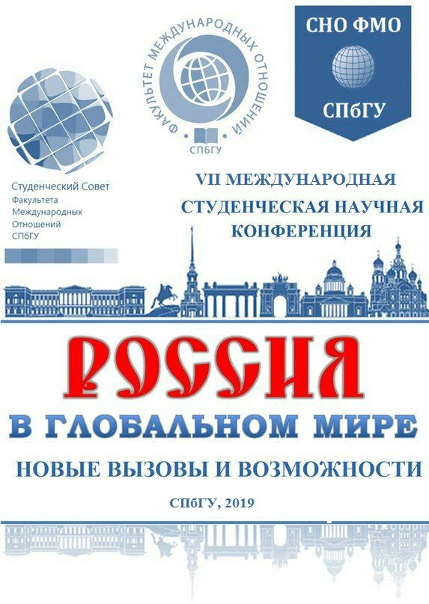
Information mail
VII International Student Scientific Conference «Russia in the global world: new challenges and opportunities»

On 29 March 2019 the Seventh International Students Scientific Conference “Russia in the Global World: New Challenges and Opportunities” takes place at the Faculty of International Relations of St. Petersburg State University

The conference will include 8 sections:

- Section «Problems of ensuring the information security of Russia»
- Section «Russia and the problems of arms control: searching for a new formula»
- Section «Relations of Russia with the countries of CEE and neighboring countries: deterrence, defense and dialogue»
- Section «Security of Russia within the context of the international political system transformation»
- Section «Russia within the system of global governance and international lawmaking»
- Section «Russia and the problem of protectionism in international trade»
- Section «Problems of promotion and perception of the image of Russia in the world community»
- Section «Digitalisation of international relations: challenges for Russia»

By the results of the conference, the best presentations made by the participants will be awarded.

Within the conference, special events for participants and guests are also planned:

- Master class on writing scientific and analytical articles
- Master class on regional studies "How to explore the country / region of your study on the example of the United States"
- Master class on social networks

Russian and foreign undergraduates and postgraduates who share academic interests common with the proposed topics are invited to participate in the conference sections. Graduate students, theoretical specialists and practitioners can also join the work of the sections and master classes.

Applications for participation in the form of theses of the planned report are accepted by 16 February 2019 at the email address: sirconf@yandex.ru. In the theses, you should supply the full name, educational institution (name of institution, department, course, name of supervisor) / place of employment, conference section. Theses of the report should include no more than 2500 characters with spaces (Times New Roman, 12 font), with a summary of the report (150 words) and keywords (5-6 words). On the basis of the theses, the section leaders - teachers of the Faculty of International Relations of St. Petersburg State University will select speakers for the conference. Following the conference, it is planned to publish an official collection of the best reports with registration in the RISC (report volume 20,000 characters with spaces, Times New Roman, 12 fonts, endnotes, see Appendix 1 for an example of design).
Travel and accommodation of participants at the expense of the directing party.

Results of the theses selection - 11 March 2019. The results will be posted in the group "In Vkontakte" (https://vk.com/sirmo_student_conf2019) and on the website www.sir.spbu.ru.
The conference program with participants and topics will be posted on the website of the Faculty of International Relations of St. Petersburg State University in mid-March 2019. www.sir.spbu.ru

Conference location: St. Petersburg, ul. Smolny, 1/3, 8 entrance

Conference organizers: Student Scientific Society in International Relations, St. Petersburg State University; Student Council, Faculty of International Relations, St. Petersburg State University

Contact Information:
Ekaterina Mikhailovna Skvortsova, sirconf@yandex.ru
Ksenia Aleksandrovna Konovalova, sirconf@yandex.ru
Daria Olegovna Matyashova, sirconf@yandex.ru
Ekaterina Nikolaevna Danilova, sirconf@yandex.ru

VKontakte groups:
Russia in the global world - 2019, https://vk.com/sirmo_student_conf2019
Student Conference the Faculty of IR SPbU 2019, https://vk.com/sir_student_conf2019

Appendix 1
An example of a footnote.
Дудина Г. Германия проходит испытание Африкой. // Коммерсантъ. 16 января 2013 г.
Локк Дж. Два трактата о правлении // Сочинения. М.: Мысль, 1988. Т. 3. С. 135–405.
Романова Т. А. Россия и ЕС: диалог на разных языках // Россия в глобальной политике. Т. 4. 2006. № 6. С. 79–92.
Сандерс Д. Международные отношения: неолиберализм и неореализм // Политическая наука: Новые направления / Ред. Р. Гудин, Х.-Д. Клингеманн. М.: Вече, 1999. С. 410–424.
Dos Santos T. The Structure of Dependence // American Economic Review. Vol. 60. Is. 2, 1970. P. 231–236.

UN Millennium Project. Investing in Development: A Practical Plan to Achieve the Millennium Development Goals. New York: United Nations, 2005. -URL://http://www.unmillenniumproject.org/reports/fullreport.htm. - 10.01.13

