Information letter

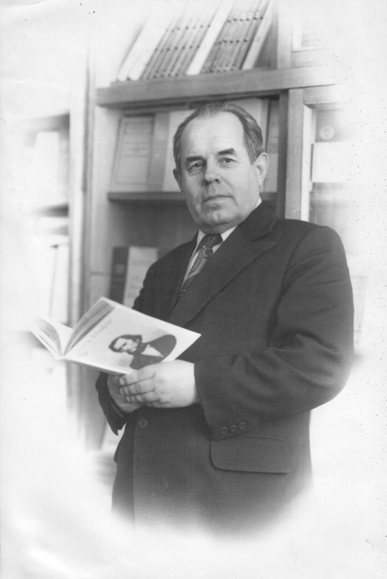
Dear friends!

We invite you to take part in the II International Psychological and Pedagogical Forum "Traditional education and technological challenges» dedicated to the 100th anniversary of famous educator A. E. Kondratenkov, which will be held on October 14-15, 2021 at the Smolensk State University (Smolensk, Russia).
The Forum will become a unique platform for leading scientists, teachers, experts and practitioners working in the field of pedagogy and psychology. The forum will provide an opportunity to present the results of breakthrough research, share knowledge and experience, and discuss current issues and trends.

Ministry of Science and Higher Education of the Russian Federation

Smolensk State University

Department of Pedagogics and Psychology

Hold

II International Psychological and Pedagogical Forum "Traditional education and technological challenges» (IPPF-2021)

October 14-15, 2021

Objectives:
- implementation of targets for the development of education in the aspect of modern requirements and directions;
- exchange of the best Russian and international experience and discussion of promising areas of personal development and achievements in the field of educational technologies;
- enhancement of academic partnerships among Russian and overseas educators, scientists, policy-makers.

Conferences of IPPF-2021:
1. The XVI International scientific conference "Teacher and Time", dedicated to the 100th anniversary of A. E. Kondratenkov
2. Scientific conference " Psychological and pedagogical problems of personality and social interaction"
3. Scientific and practical conference "Educational work of a modern educational organization: theory and practice"

The conference sub-themes:
The teacher in the modern cultural and educational environment.
Professional and pedagogical training of a teacher as moral agents in the XXI century.
Historical and pedagogical aspects of the development of education.
Pedagogy of higher education in the system of the world educational process.
Modern models of personal development in the conditions of residential organizations.
Actual problems of special pedagogy and psychology.
Psychological and pedagogical support of devictimization of subjects of the educational process.
Formation of pedagogical mentality in the process of professionalization.
Professional identity of a modern teacher.
Problems of modern career guidance work.
Actual problems of education of moral values of youth.
Modern educational technologies in educational work.
University students as a special social category.
Theory and methodology of educational activity in educational organizations.
Management of educational work in educational organizations and monitoring of the quality of the organization of educational activities.

IPPF-2021 will take place both on-campus and online on October 14-15, 2021.

Form of participation:
• Presentation of a report at the plenary session (up to15–20 minutes);
• Presentation of a report at the thematic session (up 10 minutes);
• Participation in the debate at the thematic session.

Form of participation:
• Presentation of a report at the plenary session (up to15–20 minutes);
• Presentation of a report at the thematic session (up 10 minutes);
• Participation in the debate at the thematic session.

Languages of the Forum: Russian and English

Forum proceedings
Forum proceedings were published in journal indexed in RSCI databases. The Forum participants are advised to prepare their papers in Russian or English languages.

Paper requirements
Materials are typed in MS Word editor. The volume of an article in the collection of conference materials is 10000—20000 printed characters of the author's material (this volume includes text, tables, a list of cited sources and figures).
For papers, A4 format is used; paragraph indent – 12,5 mm; indent for the left margin - 25 mm, top - 25 mm, right - 25 mm, bottom - 25 mm. The font of the main text is 14 p., auxiliary (information about the author, list of cited sources, figure captions, titles and table contents) - 12 p.; single line spacing.
Pages are not numbered. Page orientation - book only; all text is typed in Times New Roman font.
Papers should contain the following information: abstract, research questions, research aim, methodology, results, conclusion and recommendations, 5-7 key words, references.
Reviewing criteria: clarity of the focus of the research, originality of the research, rigor of the research, significance of the research for education practice, policy or theory.
Papers are submitted via https://lomonosov-msu.ru/rus/event/6790/. The submission portal is open on October 1, 2021.

Registration fee
The registration fee is paid after the acceptance letter is received. The registration fee is 1200 rubles for Russian and 15 euros for foreign participants. The fee includes the Forum Proceedings (indexed in the RSCI database), participation certificates, a cultural program, coffee breaks, the costs IT services.

Important dates
October 1, 2021 – initial registration and submission deadline
October 5, 2021 – acceptance/rejection notifications are sent out
October 7, 2021 – the Forum Programme is available online.
October 13, 2021 – deadline to pay the participation fees

Please contact us at pedagogik1@yandex.ru for more information and queries

Organizing Committee

IPPF-2021 Organizing committee Chair:
Nikolay P. Senchenkov, D.Sc., Prof., Head of the Department of Pedagogy and Psychology of the Smolensk State University.

IPPF-2021 Co-chairs:
Mikhail V. Boguslavsky, D.Sc., Prof., Corresponding Member of the Academic of Russian Academy of Education, Head of the Center for the History of Pedagogy and Education of the Institute of Educational Development Strategy of the RAO;
Nina N. Rozanova - PhD, Associate Professor, Head of the Department of Scientific Work of the Smolensk State University.

Members of the scientific committee:
Sergei A. Kremen, PhD, Associate Professor, Department of Pedagogy and Psychology, Smolensk State University (Smolensk, Russia);
Airisa Shteynberga, Asoc. prof. Dr. psych., Head of the Institute of Humanities, Riga Technical University (Riga, Latvia);
Ludmila Shepelevich, D.Sc., Prof., University of Warsaw (Warsaw, Poland);
Sebastian Hacker, Chairman of the Association of Teachers and Professors of the Russian Language of Austria (Vienna, Austria);
Ausma Shpona, Doctor habil.paed., Expert of the Latvian Academy of Sciences (Latvia, Riga);
Mara Vidnere, Dr. habil. psych., Dr.oec., Latvian Academy of Sciences (Riga, Latvia);
Vladimir V. Selivanov, D.Sc., Prof., Head of the Department of General Psychology, Smolensk State University (Smolensk, Russia);
Natalia Yu. Naletova, D.Sc., Prof., Department of Pedagogy and Psychology, Smolensk State University (Smolensk, Russia);
Ludmila N. Selivanova, PhD, Associate Professor, Department of Pedagogy and Psychology, Smolensk State University (Smolensk, Russia);
Oksana A. Anisimova, PhD, Associate Professor, Department of Pedagogy and Psychology, Smolensk State University (Smolensk, Russia);
Roman V. Belyutin, D.Sc., Prof., Head of the Department of German Language, Smolensk State University (Smolensk, Russia).

