Title of the work (bold, center alignment,
writing in the usual format, not all capital letters)
Ivanov I.A., ¹ Petrov I.B. ^{1,2} (the first author must indicate the speaker)
Student, 4th year of the specialty (italics, indicated only for the speaker)
¹ Moscow State University named after M.V. Lomonosov,
Faculty of Chemistry, Moscow, Russia
² Kazan (Volga Region) Federal University,
Institute of Chemistry named after V.I. A.M. Butlerova, Kazan, Russia
(affiliations are indicated for all authors, each on a new line, only those that differ are numbered)
E-mail: ivanov@yandex.ru (for presenter only)
Design and formatting of abstracts submitted to the section "Chemistry": file format - doc or docx , page size - A4, orientation - portrait. Margins: top and bottom - 20 mm, left and right - 24 mm. Font throughout the document - Times New Roman , 12 pt , single spacing for the entire text, including paragraphs, the beginning of a new paragraph is indented from the left 0.7 cm (except for the header, there are no indents in it), the total volume of the entire abstract file is no more than 1 page .
The title of the work, authors, status of the speaker, places of work of all authors and the e - mail of the speaker are given in order and on separate lines (see above for the design). The status of the speaker is indicated in the form “ Student, N course of a specialty (bachelor’s, master’s) ”, “ Postgraduate student, N year of study ” for students and postgraduates, or “ Position ” for young scientists. The main text of the abstract begins with the next line after the header (justified alignment). Empty lines should not be anywhere!
Throughout the text, a space must be left between the last digit of the number and the unit designation (10%, 20 wt.%, 30 ºС, 298 K). It is recommended to use a dot as a decimal separator, and a dash "-" for the minus sign.
Mathematical formulas, symbols and chemical reactions are typed using the built-in MS Word tool "Formula" either in Microsoft Equation , are placed on separate lines (center alignment) and numbered (to the right in parentheses through tabs). The numbering is end-to-end and is given in the order of appearance, and only formulas (equations) that are referenced in the text are numbered. Structural formulas and complex chemical reactions are inserted as pictures; pasting schemes directly by copying from Chem S ketch or ChemD raw programs is not allowed (see requirements below).
$С_{p}\left(T\right)=3R\sum_{i}{α_{i}\frac{{\left(\frac{Θ_{i}}{T}\right)}^{2}e^{\frac{Θ_{i}}{T}}}{{\left(e^{\frac{Θ_{i}}{T}}-1\right)}^{2}}}$ (1)
SiF _{4 gas} + 2 H _{2 gas} + O _{2 gas} → SiO _{2 TV} + 4 HF _{gas} - 384 kJ (2)

Figures and graphs are inserted in separate paragraphs (text wrapping “top and bottom”, distances 0 cm) and are accompanied by a caption like “Fig. N. _ Title” (center alignment, no dot at the end). It is recommended to leave one blank line before the figure and after the caption. Images must be clear and have a resolution of 300-600 ppi (both black and white and color are allowed). The file formats are tiff , jpeg or png .

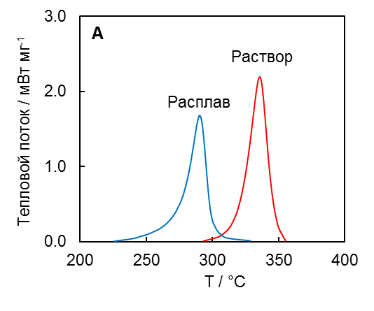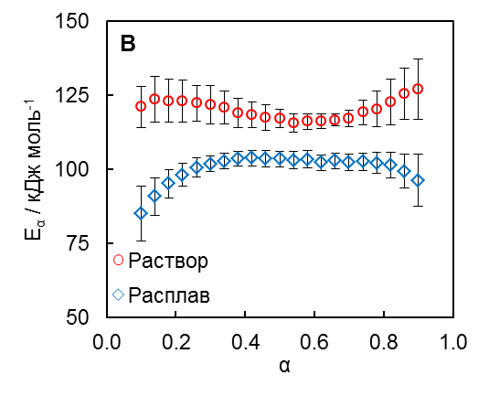
Rice. 1. A DSC curves of polymerization of the studied aryl cyanate in melt and solution at 4 K/min; B Activation Energy vs. Conversion for Melt and Solution Polymerizations

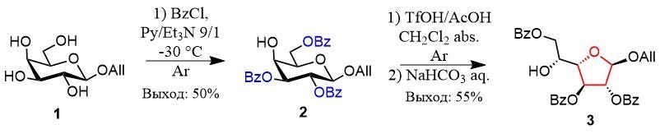
Scheme 1. Synthesis of galactofuranose glycosyl acceptor

Tables are inserted in separate paragraphs, they are necessarily preceded by the name of the form “ Table N. Title” (left-aligned, no dot at the end). Do not tint table headers, do not use bold font. Separate table cells should be highlighted with color only if it carries an important semantic load. It is allowed to reduce the font size to 11 pt. It is recommended to leave one empty line before the heading and after the table.
We advise you to work on compiling your abstracts immediately in the template file, or insert your own text one paragraph at a time into this template, keeping the formatting. Unnecessary template lines are removed.

Table 1. Standard thermodynamic functions of silicon at 298.15 K
 | $$c_{p}$$ | $$S°$$ | $$H°\left(298.15\right)-H°(0)$$ | Standard deviations ( abs .)
 |  |  |  | $$c_{p}$$ | $$S°$$ | $$H°\left(298.15\right)-H°(0)$$
 | J mol ^{–1} K ^{–1} |  | J mol ^{–1} | J mol ^{–1} K ^{–1} |  | J mol ^{–1}
Nast. Job | 20 . 034 | 18 . 794 | 3214.6 | 0.0 12 | 0.0 16 | 1 . 4
NIST-JANAF [3] | 20.00 0 | 18.82 0 | 3217.9 | — | — | —

Acknowledgments, grant support and other sources of funding are indicated in italics at the end of the abstract text in a separate paragraph before the list of references.
Literature
The list of references is given numbered in the order in which the work is mentioned in the text of the abstract and is drawn up in accordance with GOST R 7.0.5-2008. Abbreviations are used for journal titles. All sources in the text of the abstract must be referenced in the form of a number in square brackets [1,2].
1. Tsai J.-C., Chen Y.-P. Application of a volume-translated Peng-Robinson equation of state on vapor-liquid equilibrium calculations // Fluid Phase Equilib . 1998 Vol. 145. P. 193-215.
2. CRC Handbook of Chemistry and Physics. 102nd Ed. / ed. Rumble JR Boca Raton, FL: CRC Press, 2021.

