Title of the work (bold, center alignment,
writing in the usual format, not all capital letters)
Ivanov I.A.,¹ Petrov I.B.^{1,2} (First author is for presenter only)
Student, 4th year of the specialty (status is only for the presenter)
¹Moscow State University named after M.V. Lomonosov,
Faculty of Chemistry, Moscow, Russia
²Kazan (Volga Region) Federal University,
Institute of Chemistry named after V.I. A.M. Butlerov, Kazan, Russia
(affiliations are required for all authors, numbered only if differs)
E-mail: ivanov@yandex.ru (for presenter only)
Design and formatting of abstracts submitted to the section "Chemistry": file format - doc or docx, page size - A4, orientation - portrait. Margins: top and bottom - 20 mm, left and right - 24 mm. Font throughout the document - Times New Roman, 12 pt, single spacing of the entire text, including paragraphs, the beginning of a new paragraph is an indent from the left of 0.7 cm (except for the header, there are no indents in it), the total length of the abstract file is no more than 1 page.
At the beginning of the file there are the title of the work, the authors, the status of the investigator, the place of work of all authors and the e-mail of the investigator (see the design above). The status of education in the form is "Student, N course of a specialty (bachelor's degree, master's degree)", "Postgraduate student, N year of study" for undergraduate and graduate students Position or "Position" for young scientists. The main text of the abstract begins with the following after the header (width alignment). Empty lines should not be anywhere!
Throughout the text, spaces must be left between the last digits and storage units (10%, 20 wt.%, 30 ºС, 298 K). It is recommended to use a period as a decimal separator, and a short number "–" for the minus sign.
Mathematical formulas, chemical reactions are typed using built-in MS Word tool "Formula" either in Microsoft the equation is spanned by a narrow string (center alignment) and numbered (right in parentheses through taboo). The numbering is end-to-end and is given in the order of discovery, and only formulas (equations) that are referenced in the text are numbered. Structural formulas and complex chemical reactions can be inserted from ChemSketch or ChemDraw programs.
$С_{p}\left(T\right)=3R\sum_{i}{α_{i}\frac{{\left(\frac{Θ_{i}}{T}\right)}^{2}e^{\frac{Θ_{i}}{T}}}{{\left(e^{\frac{Θ_{i}}{T}}-1\right)}^{2}}}$ (1)
SiF_{4 gas} + 2 H_{2 gas} + O_{2 gas} → SiO_{2 TV} + 4HF _{gas} – 384 kJ (2)

Figures and plots are placed in separate paragraphs (text wrapping “on top and visible”, appearance 0 cm) and are accompanied by the appearance of a caption like “Fig. N . Title” (center alignment, no dot at the end). Add one empty line before and after the figure. Figures must be clear and have a resolution of 300-600 ppi (b/w or color). The file formats are tiff , jpeg or png .

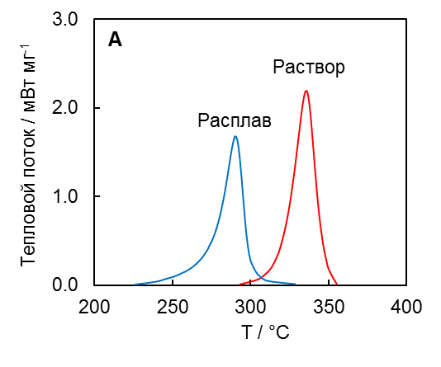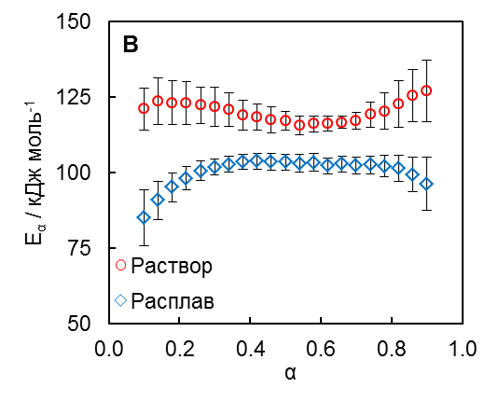
Fig. 1. A DSC polymerization curves of American aryl cyanate in melt and solution at 4 K/min; B Dependence of activation energy on conversion for melt and solution polymerization

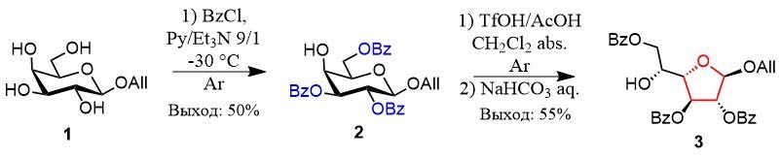
Scheme 1. Synthesis of galactofuranose glycosyl acceptors

Tables are supplied in as separate paragraphs, they are necessarily preceded by the name of the form “Table N. Title” (left-aligned, no dot at the end). Do not tint table headers, do not use bold font, use highlights only if it has a significant semantic load. Font size can be reduced to 11 pt. Add one empty line before and after the table.
We advise you to work on compiling your abstracts immediately in this template file or insert your own text into this template keeping the formatting. Unnecessary template lines can be removed.

Table 1. Standard thermodynamic functions of silicon at 298.15 K
 | $$c_{p}$$ | $$S°$$ | $$H°\left(298.15\right)-H°(0)$$ | Standard deviations (abs.)
 |  |  |  | $$c_{p}$$ | $$S°$$ | $$H°\left(298.15\right)-H°(0)$$
 | J mol ^{–1} K ^{–1} |  | J mol ^{–1} | J mol ^{–1} K ^{–1} |  | J mol ^{–1}
Nast. Job | 20.034 | 18.794 | 3214.6 | 0.0 12 | 0.0 16 | 1.4
NIST-JANAF [3] | 20.00 0 | 18.82 0 | 3217.9 | — | — | —

Acknowledgments, grant support and sources of funding are gradually accumulated at the end of the abstract text in a separate paragraph before the references.
References
The list of references is given numbered in the order in which the work is mentioned in the text of the abstract and is drawn up in accordance with GOST R 7.0.5-2008. For all sources in the text of the abstract, a reference to the type of number in square brackets [1,2] is required.
1. Cai J.-K., Chen Y.-P. Application of the Peng-Robinson Equation of State with Volume Transformation to Vapor-Liquid Equilibrium Calculations // Fluid Phase Equilib. 1998. Vol. 145. S. 193-215.
2. CRC Handbook of Chemistry and Physics. 102nd ed. / ed. Rumble J.R. Boca Raton, FL: CRC Press, 2021.

